Welcome to A Level Politics!

We are delighted that you have chosen to take A Level Politics and that you have this unique opportunity to set the foundations of your political knowledge before you begin life in sixth form.

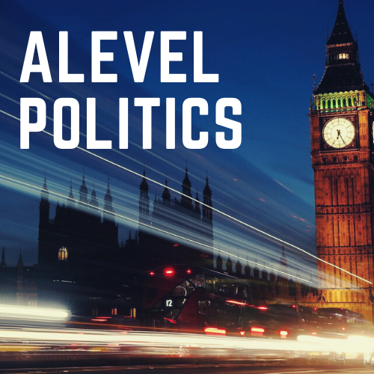

What should you expect?

A lot of debate! Politics is a discursive subject. We consider really thorny issues and quite complex ideas. Debate encourages us to engage critically with our subject matter and, crucially, to see things from multiple perspectives.

It is also a highly emotive subject. However objective we may consider ourselves to be, we cannot escape from the fact that we bring our own ideas, worldviews, values to every lesson. We are human and we are subjective. We are also not always fully aware of the ideas that we have formulated ourselves or those which we have received from our upbringing, our social class, our schooling and the media with which we engage. Studying politics encourages you to be more aware of the influencers of your own political ideas and those of others.

Embark on the course with an open mind. Be questioning and be critical of your own ideas and of others. Listen to others. Really listen. Try to understand where they are coming from and the principles that underpin their ideas. And, above all, enjoy learning about the world we live in today, understanding the power relationships that exists between the individual and the state and getting closer to the crux of human nature.

Who will be teaching you?

You will either be taught by Ms Webb, Mr Turner or Ms Hunn.

What does the course look like?

Year 1 | Politics of the UK and ideologies | Government of the UK and ideologies
Autumn Term | Democracy  Conservatism  Socialism | Liberalism  The UK Constitution  Parliament
Spring Term | Political Parties  Voting behaviour | The Prime Minister and the Executive  Relationship between branches
Summer Term | Electoral systems | Nationalism
Year 2
Autumn Term | Global theories  The state and globalisation | Global governance: political and economic
Spring Term | Power and developments  Regionalism | Global governance: human rights  Global governance: environment
Summer Term | Revision and Exams | Revision and Exams

Summer tasks
Task 1 – total time: 5 hours
Watch Andrew Marr’s A History of Modern Britain here: https://whs.fireflycloud.net/politics/a-level/summer-preparation
Complete the table as you watch the documentary:
Prime Minister | Dates as PM | Political Party in power | Key features

What have been the key turning points or changes in British politics since WW2?
What similarities and differences do you notice between the prime ministers?
What similarities and differences do you notice between the political parties?

Task 2 - current affairs
This is a little more open ended. I’d like you to pick one news story over the summer and read about the issue in different newspapers (aim for at least 3 across the political spectrum). Be ready to share what you have read and your thoughts about this in a whole class discussion during our first few lessons in September. There are some questions to help you below.
- BBC news: this is a good starting point to get the gist of a story or issue.
- The Guardian: this is the more left-wing and liberal of the newspapers.
- The Telegraph: often dubbed the ‘Torygraph’, this will give you more of a sense of the right-wing’s perspective.
- The Times or the Financial Times or the Economist may give you a more centralist perspective.
- It may also be worth dipping into a tabloid paper such as the Sun or the Mirror as you can see from the second table below, these are the most widely read in the UK.

Table 1 – for information only – the political leanings of the UK press (taken from YouGov)
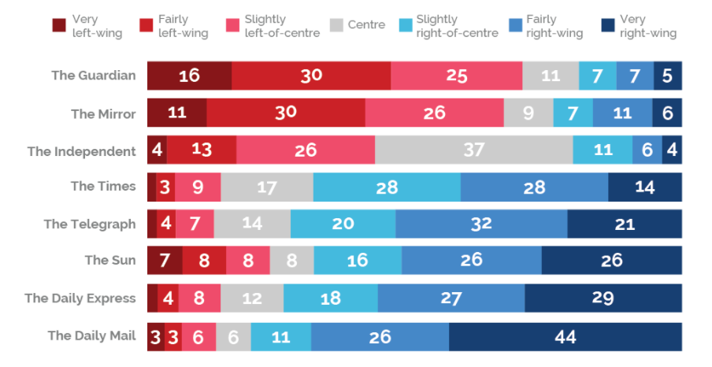
Table 2 – the circulation of UK newspapers – taken from Wikipedia
Title | 2017^{[8]} | 2016^{[9]} | 2015^{[10]} | 2014^{[11]} | 2013^{[12]} | 2012^{[13]} | 2011^{[14]} | 2010^{[15][16]}
The Sun | 1,666,715 | 1,787,096 | 1,978,702 | 2,213,659 | 2,409,811 | 2,582,301 | 3,001,822 | 3,006,565
Daily Mail | 1,511,357 | 1,589,471 | 1,688,727 | 1,780,565 | 1,863,151 | 1,945,496 | 2,136,568 | 2,120,347
Metro | 1,476,956 | 1,348,033 | ? | 1,362,893^{[17]} | ? | ? | ? | ?
Evening Standard | 887,253 | 898,407 | 877,532^{[18]} | 805,309^{[19]} | 695,645^{[20]} | 699,368^{[21]} | 704,008^{[22]} | 601,960^{[23]}
Daily Mirror | 724,888 | 809,147 | 922,235 | 992,256 | 1,058,488 | 1,102,810 | 1,194,097 | 1,218,425
Daily Telegraph | 472,258 | 472,033 | 494,675 | 544,546 | 555,817 | 578,774 | 651,184 | 691,128
The Times | 451,261 | 404,155 | 396,621 | 384,304 | 399,339 | 397,549 | 457,250 | 508,250
Daily Star | 443,452 | 470,369 | 425,246 | 489,067 | 535,957 | 617,082 | 734,311 | 779,376
Daily Express | 392,526 | 408,700 | 457,914 | 500,473 | 529,648 | 577,543 | 639,875 | 674,640
i | 266,768 | 271,859 | 280,351 | 298,266 | 293,946 | 264,432 | 133,472 | N/A
Financial Times | 188,924 | 198,237 | 219,444 | 234,193 | 275,375 | 316,493 | 383,067 | 390,315
The Guardian | 156,756 | 164,163 | 185,429 | 207,958 | 204,440 | 215,988 | 279,308 | 302,285
Daily Record | 155,772 | 176,892 | 203,725 | 227,639 | 251,535 | 291,825 | 306,872 | 323,831
City A.M. | 90,319 | 97,259 | ? | ? | ? | ? | ? | ?
The Independent | N/A | 55,193 | 61,338 | 66,576 | 76,802 | 105,160 | 185,035 | 185,815
The New Day | N/A | 40,000^{[24]} | N/A | N/A | N/A | N/A | N/A | N/A
The New European | 20,000^{[25]} | N/A | N/A | N/A | N/A | N/A | N/A | N/A

From <https://en.wikipedia.org/wiki/List_of_newspapers_in_the_United_Kingdom_by_circulation>

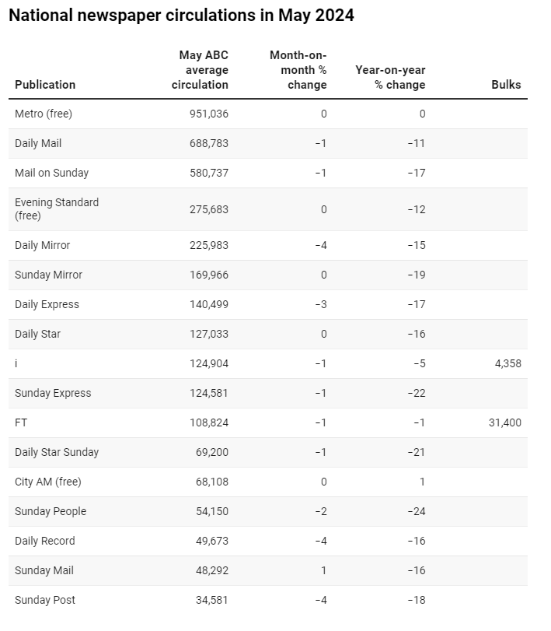 https://pressgazette.co.uk/media-audience-and-business-data/media_metrics/most-popular-newspapers-uk-abc-monthly-circulation-figures-2/

Task 3 – 30 minutes - watch BBC Parliament on a Wednesday during Prime Minister’s Questions (or PMQs): https://www.bbc.co.uk/iplayer/episode/m000wj87/prime-ministers-questions-26052021 You will need to do this before the 22nd July as this is when summer recess begins and so Parliament does not sit.
What observations do you have about the House of Commons?
Things to consider:
- Who is sitting where?
- What is the role of the PM in PMQs?
- What is the role of the opposition leader, Keir Starmer?
- What are the key issues of the day that the PM is being questioned about?

And those of you up for an extra challenge, can dip into the following:
A.C. Grayling Democracy and its Crisis
Isabel Hardman Why we get the wrong politicians

