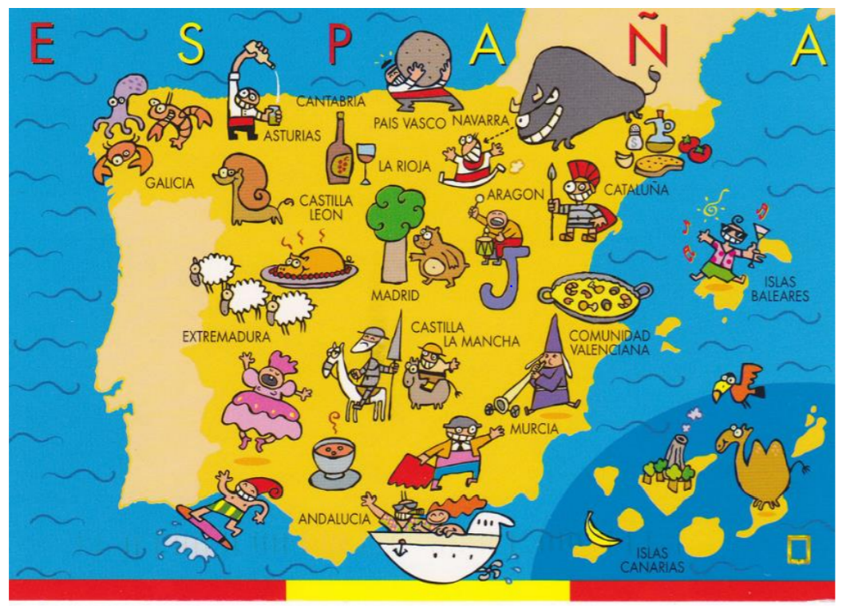

PREPARING TO STUDY A-LEVEL SPANISH – A GUIDE
This guide aims to answer the following questions:
1. What are the exams like?
2. Which topics are covered?
3. What background knowledge would be useful?
4. Which language skills should I practise, and how?
5. Which programmes and films could I watch?
6. Which online courses could I take?
7. What preparatory work is compulsory?
8. Where can I get more support or suggestions?

Overview of the A-level course

1. What are the exams like?
Paper | Weighting | What is assessed? | Duration | Total marks
Paper 1: Listening, reading and translation | 40% | - Section A: listening (30 marks)  - Section B: reading (30 marks)  - Section C: translation into English (20 marks) | 2 hours | 80
Paper 2: Writing | 30% | - Translation into Spanish (20 marks)  - Essay on prescribed literature from a choice of two (50 marks)  - Essay on prescribed film from a choice of two (50 marks) | 2 hours 40 mins | 120
Paper 3: Speaking | 30% | - Discussion based on stimulus card (30 marks)  - Independent Research Project presentation & discussion (42 marks) | 5 mins prep time  16-18 mins exam time | 72

2. Which topics are covered?
The A-level Spanish course builds on topics at GCSE and introduces new, more complex ones. Many of them are topical and link to what you may be studying in other subjects, such as Politics and History.
Theme 1: La evolución de la sociedad española
Changes in family structures, the world of work, the impact of tourism in Spain
Theme 2: La cultura política y artística en el mundo hispanohablante
Music, the media, festivals and traditions
Theme 3: La inmigración y la sociedad multicultural española
The positive impact, challenges and social reaction towards immigration in Spain
Theme 4: La dictadura franquista y la transición a la democracia
The role of King Juan Carlos in the transition, Suárez’s government, the 1981 Coup

We study a film (Volver by Pedro Almodóvar) and a play (La casa de Bernada Alba by Lorca) over the two years of the A-level course.
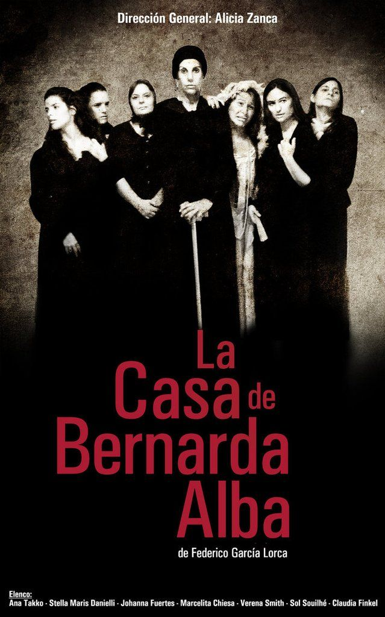


3. What background knowledge would be useful?
You do not have to be an expert in all of these topics – we recommend researching as many as you can, in English or Spanish:
- Where Spanish speaking countries are located in the world
- The culture of different Spanish speaking countries e.g. music, film, food, literature, landmarks
- The political situation in different Spanish speaking countries e.g. are they monarchies, dictatorships, democracies? What are the biggest issues in these countries? What is life like for young people?
- The Spanish civil war – causes and consequences
- Franco’s dictatorship – what was life like in Spain during this time?
Once you actually start your A Level in September, you will realise that you are
almost completing a Sociology A Level in Spanish. It is fascinating and you will learn
all about the history and culture of Spanish speakers across the world, not just in
Spain.

If you are searching for information, try switching to the Spanish
www.es.wikipedia. Remember that anyone can write on Wikipedia so you
must validate your research elsewhere and never quote
from it! It is a good place to start though.
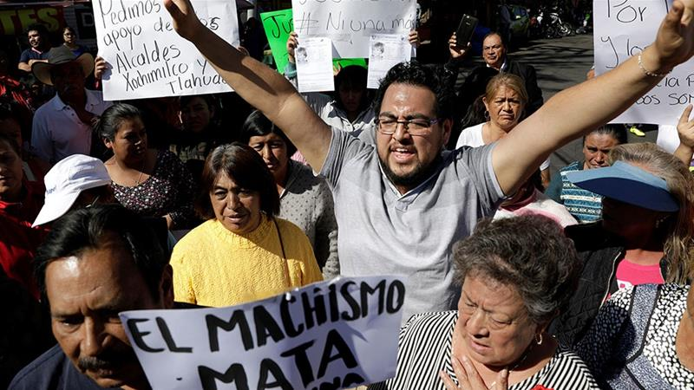
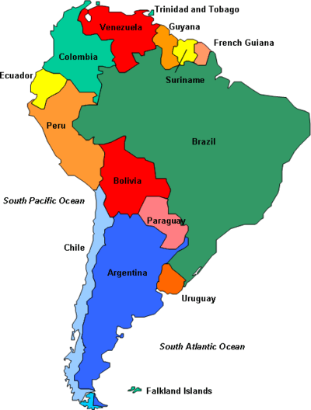
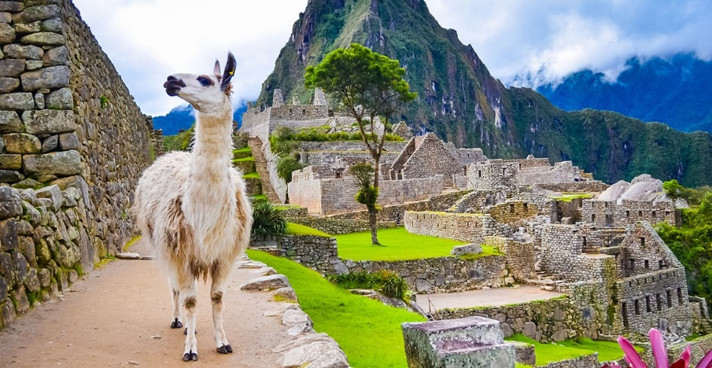

4. Which language skills should I work on, and how?
Grammar
You should revise what you have already covered at GCSE so that you are secure on it:
Recognise and use a range of tenses with regular and irregular verbs. | Regular –AR, -ER and -IR verbs in the following tenses  AND  Common irregular verbs e.g. ser, tener, hacer, ir in the following tenses  - Present  - Perfect  - Preterite  - Imperfect  - Pluperfect  - Near Future  - True Future  - Conditional
Give opinions and reasons | - A range of opinion expressions  - Positive and negative reasons for opinions  - Use of impersonal verbs like gustar and encantar

If you feel confident with the GCSE content, you can start learning new tenses. We suggest starting with the future perfect, conditional perfect and present subjunctive.
Where can I practise grammar?
- Languages online: www.languagesonline.org.uk
- Seneca: www.senecalearning.com (you need to register first then search for Spanish courses)
- BBC Bitesize: https://www.bbc.co.uk/bitesize/subjects/z9mtsbk
Reading & listening
The most important thing is that you listen to and read as much as Spanish as you can, so explore the links below and find what suits you best. Keep your own vocabulary book for new expressions you come across. You could order it alphabetically, by topic area or just use it as a diary and scribble away your Spanish development in it.
Online newspapers and magazines, for example:
- www.20minutos.es
- www.elpais.es
- www.bbc.com/mundo
- www.rtve.es/Noticias - click on Telediario en 4 to watch four minute version of the news. Alternatively, you can watch the entire news show which lasts 50 minutes.

Other websites:
- www.lyricstraining.com (fun way to practise listening through songs)
- www.ver-taal.com (vocabulary, grammar and listening exercises)

Books:
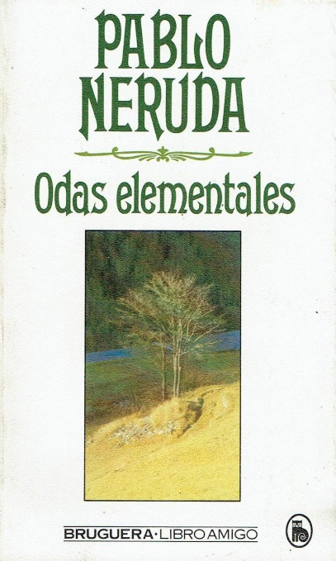
You may want to start with books you are familiar with, translated into Spanish, such as Harry Potter. Or, you can begin to explore the exciting world of Hispanic literature – here are some suggestions:
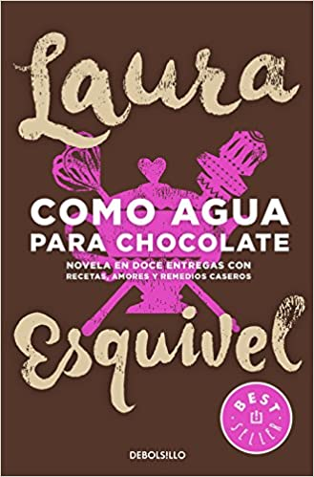
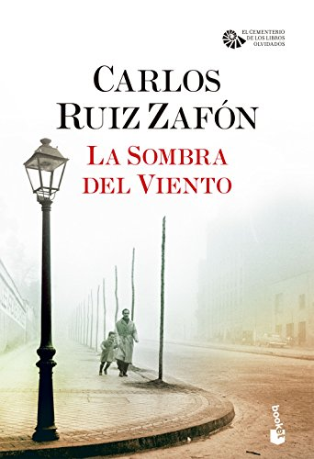
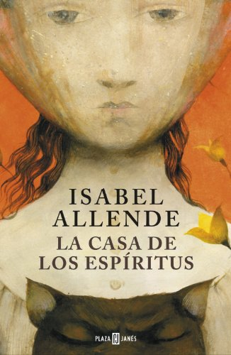

TOP TIP: Don’t look up every word you are not sure of when reading an article/ book, as it will take you forever. Skim and scan the text to get the gist.
Remember to use the context or the article, cognates and common sense to figure out what the article is saying.
Pick out a couple of words that you like the look of, that you feel may be real hurdles to getting the idea of the text, look them up carefully and add them to your vocab booklet.
The aim at this stage is to get the gist of the text, not be able to translate it completely. Translation is a whole different ball game and you will learn it soon enough. You will be surprised how much more enjoyable reading will be if you really pay attention to this tip.
5. Which programmes and films could I watch?
First, check out these tips on how to watch foreign language TV shows or films in a way that enables you to develop your language learning: https://www.fluentin3months.com/movies/
Suggested programmes:
- La Casa de Papel
- Las Chicas del Cable
- Fugitiva
- El Chapo
You can find many more suggestions here: https://www.secondhalftravels.com/spanish-language-tv-shows-netflix/
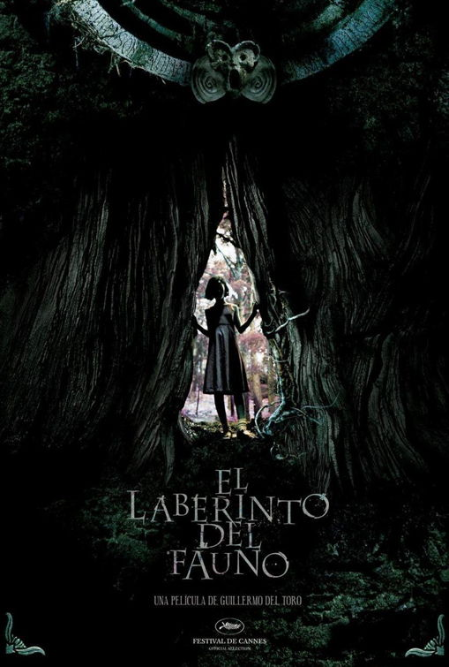
Suggested films:
- Ocho Apellidos Vascos (Emilio MartínezLázaro, 2014)
- El Laberinto del Fauno (Guillermo del Toro, 2006)
- María llena eres de gracia (Joshua Marston, 2004)
- Abel (Diego Luna, 2010
- Las 13 Rosas (Emilio Martínez-Lázaro, 2007)
You can find many more suggestions here: https://www.secondhalftravels.com/spanish-movies-netflix/


We suggest you complete the following tasks when watching programmes and films:
Contesta en español:
- ¿De qué trata la serie / película?
- ¿Qué opinas del programa / de la serie / película?
- ¿Recomendarías esta serie a un amigo? ¿Por qué?

Reflect:
- How much Spanish could you understand when you watched the TV programme / film? Which words or phrases do you remember?

- What might you do next time to improve on this?


6. Which online courses could I take?
There are lots of free online courses that cover topics relevant to the Spanish-speaking world, both in English and in Spanish. Our recommendations are:
- Historia de México course on www.senecalearning.com (you need to register first)

- Intermediate Spanish: Literature, Cinema and the Visual Arts https://www.futurelearn.com/courses/intermediate-spanish-culture-and-leisure-in-the-spanish-speaking-worlds-contemporary-literature-cinema-and-the-visual-arts
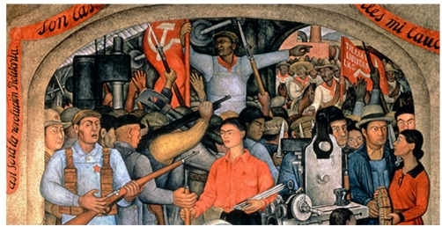
- Art and the Mexican Revolution: https://www.open.edu/openlearn/history-the-arts/art-and-the-mexican-revolution/content-section-0?active-tab=description-tab

- Intermediate Spanish: A trip across Latin America: https://www.open.edu/openlearn/languages/intermediate-spanish-a-trip-across-latin-america/content-section-0?active-tab=description-tab
7. What preparatory work is compulsory?
We expect all students to have done the following as a minimum in preparation for starting A-level Spanish in September:
- Watch the film Volver (2006) by Pedro Almodóvar. Please buy a copy from amazon.es so that the subtitles are in Spanish – this is very important! There is a version that you can watch on Planet eStream, but it’s subtitled in English.

- Read the play La Casa de Bernarda Alba by Federico Garcia Lorca – please buy a copy of the Bloomsbury bilingual student version (green horse image on front cover!).

- Identify your preferred sources for reading and listening that you will use for regular independent practice. Start using them at least once or twice weekly

- Review your grammar knowledge and understanding; revise and practise any tenses or structures from GCSE where you are not 100% confident.
8. Where can I get more support or suggestions?
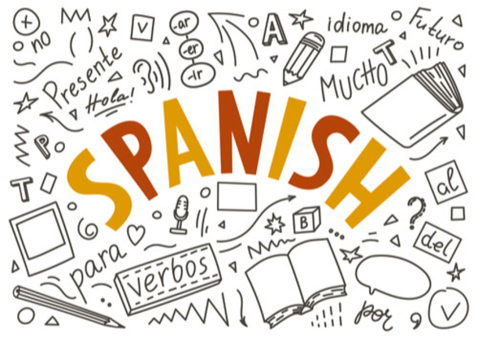
Email your Spanish teacher if you have any other questions about studying A-level Spanish.

See you in Year 12!

