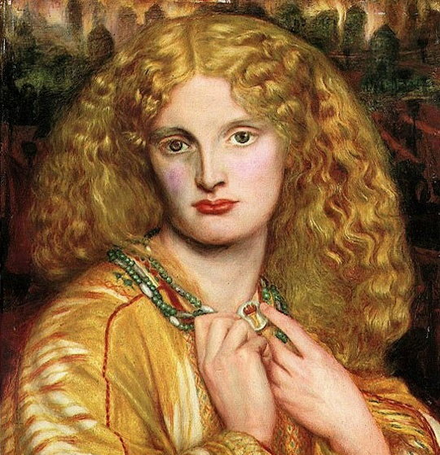

A Level
Classical Civilisation
Student Booklet

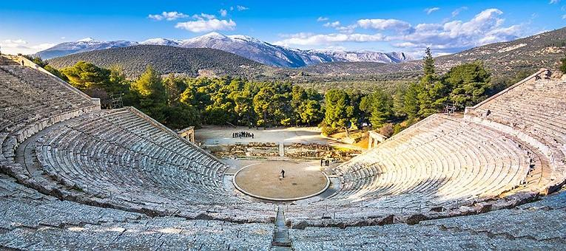
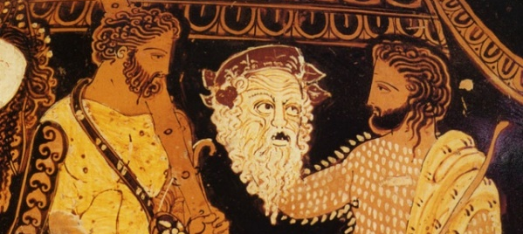

Overview of the three A Level Modules:
In Year 12 you will study modules [01(a)] & [02]; in Year 13 you will study modules [01(b)] & [03]
[01] The World of the Hero  2 hr 20 min exam; 100 marks | You will study two great epic poems:  (a) Year 12: Homer’s Iliad  [Context Books: 1, 3, 4, 6, 9, 10, 16 – 19, 22 – 24]  (b) Year 13: Virgil’s Aeneid  [Context Books: 1, 2, 4, 6 – 12]
[02] Greek Theatre  1 hr 45 min exam; 75 marks | You will study three renowned Greek plays:  Sophocles Oedipus the King  Euripides Bacchae  Aristophanes Frogs
[03] Love and Relationships  1 hr 45 min exam; 75 marks | You will study works by the archaic Greek lyric poet Sappho, the philosopher Plato, the Roman poet Ovid and the Stoic philosopher Seneca. You will consider questions such as: What are the ideal qualities (& relative status) of men & women? What makes a good marriage? Should adultery be tolerated? How should we define ‘love’? What is the difference between love and desire? Can (or should) desire be resisted or controlled?

Preparatory Tasks before starting the A Level Classical Civilisation course:

- Books to buy:
1. Homer’s Iliad, translated by E. V. Rieu, revised by D. C. H. Rieu & Peter Jones (Penguin Classics)
2. The World of the Hero Sally Knights (OCR/Bloomsbury)
3. Sophocles The Theban Plays, translated by R. Fagles (Penguin Classics)
4. Euripides Bacchae, Cambridge Translations from Greek Drama (ed. D. Franklin, C. U. P.)
5. Aristophanes Frogs, Cambridge Translations from Greek Drama (ed. J. Affleck & C. Letchford, C. U. P.)

- Reading:
1. As much of Homer’s Iliad as you can read; try to read at least the first six Books (= pages 3 – 114).
2. One novel based on Homer and one on Greek tragedy. Ask any of the Classics department for advice on what to go with!

- Films/videos to watch and podcasts to listen to:

1. Troy (the movie) [Amazon Prime]
2. Troy: Fall of a City [Netflix]
3. In Search of the Trojan War (Michael Wood)
https://www.youtube.com/watch?v=CkbUQKyie_w
4. In Our Time: The Iliad - https://www.bbc.co.uk/programmes/b0bh5x1y
5. Introduction to Greek Tragedy (National Theatre):
https://www.youtube.com/watch?v=dSr6mP-zxUc
6. Ancient Greece: The Greatest Show on Earth 1:
https://www.youtube.com/watch?v=FAkLTWQUbG8
7. In our time on Greek Tragedy - https://www.bbc.co.uk/programmes/p005464v
8. In our time on Greek Comedy - https://www.bbc.co.uk/programmes/p003c1d3
9. Natalie Haynes stands up for Classics
e.g. Jocasta, Euripides, Aristophanes, Sophocles, the Iliad
10. Among the Ancients with Emily Wilson - https://www.lrb.co.uk/podcasts-and-videos/podcasts/close-readings/among-the-ancients-the-iliad
What the Classics Department expects of you:

In lessons:
- Come prepared with the right materials.
- Contribute actively and enthusiastically.
- Don’t worry about getting a question wrong: be bold: have a go.
- Show a lively interest in the subject matter by asking frequent questions; be curious.
- Expect to work hard in lessons.

Homework:
- Make sure you meet all deadlines.
- Spend sufficient time on your work: in year 12 work for each half of the course should take c. 2 – 2.5 hours per week, i.e. c. 4 – 5 hours per week in total.
- Ask for help if you are finding a particular task difficult; don’t submit incomplete work.

Exploring beyond the specification:
- Try to read beyond what is required by the A Level syllabus (see ‘Recommended Further Reading’ for some suggestions)
- Make sure you accompany the Department’s trips to see productions of classical plays
- Explore novels, poems, films, works of art or pieces of music which are inspired by classical influences (ask for recommendations)
- Visit museums, galleries & exhibitions
- Consider going to a classical summer school (ask for a list of Summer Schools)
- If you are interested in pursuing a classical course or subject at university, ask a member of the Dept. for advice; start researching university Classics courses independently Visit Oxford &/or Cambridge and be inspired by the dreaming spires

Recommended Further Reading [ = highly recommended!]

- Classics: A Very Short Introduction, Mary Beard & John Henderson (O. U. P.)
- Classical Literature: A Very Short Introduction, William Allan (O. U. P.)
- The Ancient Greeks, Edith Hall (Vintage)
- The Ancient Guide to Modern Life, Natalie Haynes (Profile Books)
- The Classical World: an Epic History of Greece and Rome, Robin Lane Fox (Penguin)
- *Homer, The Iliad, Caroline Alexander (Vintage)
- *Homer, The Odyssey, Emily Wilson (Norton)
- *The Mighty Dead: Why Homer Matters, Adam Nicolson (William Collins)
- *The Song of Achilles & *Circe, Madeline Miller (Bloomsbury) [*NB two separate novels]
- The Amber Fury; The Children of Jocasta; and A Thousand Ships, (3 novels), Natalie Haynes
- Helen of Troy, Bettany Hughes (Vintage)
- *The Silence of the Girls, Pat Barker (Penguin)
- *Troy, Stephen Fry (Penguin)
- Greek Tragedy: An Introduction, Marian Baldock (Bristol Classical Press)
- Love, Sex & Tragedy, Simon Goldhill (Murray)
- Sexuality in Greek & Roman Culture, Marilyn Skinner (Wiley Blackwell)
- Searching for Sappho, Philip Freeman (Norton)
- Sex on Show, Caroline Vout (British Museum Press)

Ideas for Places to Visit & Things to Do:

- British Museum, London: (www.britishmuseum.org);
- Fitzwilliam Museum, Cambridge:
(http://www.fitzmuseum.cam.ac.uk/)
- Museum of Classical Archaeology, Cambridge: visit the Cast Gallery (www.classics.cam.ac.uk/)
- Ashmolean Museum, Oxford: https://artuk.org/visit/venues/the-ashmolean-museum-of-art-and-archaeology-5990
- Virtual Museum Visits: https://www.theguardian.com/travel/2020/mar/23/10-of-the-worlds-best-virtual-museum-and-art-gallery-tours There are lots out there to enjoy!
- Oxford & Cambridge Greek Plays: every three years Oxford & Cambridge Universities each produce a Greek play. Recent plays have included Euripides’ Orestes [2021] & Sophocles’ Oedipus at Colonus [2019]
- Attend a Classics Summer School (ask for a list of classical Summer Schools)
- Get digging! Take part in an archaeological dig: (http://www.archaeology.co.uk/digs); (http://digs.bib-arch.org/digs/); (http://www.heritageopendays.org.uk/blog/get-your-hands-dirty-this-summer)
- Go to Greece: as soon as you can, get your parents to take you to Greece and visit Athens, Delphi, Olympia, Mycenae, Tiryns, Epidaurus, Aegina, Bassae and many other fascinating places (ask the Dept. for recommendations)

