GCSE to A-level progression: Student transition activities – Chemistry
Student booklet with information about:
- the specification and structure of the assessment
- and key skills activities to support the move from GCSE to A-level Chemistry.
Published: November 2020

Contents | Page
Understanding the specification and the assessment | 3-8
Transition activity 1-3 Scientific vocabulary | 10-12
Transition activity 4 SI units and prefixes | 14
Transition activity 5 Converting data | 15
Transition activity 6 Using the delta symbol | 16
Transition activity 7 Practical skills: Electrolysis | 17-19
Transition activity 8 Using maths skills | 20-21
Transition activity 9 Atoms | 23
Transition activity 10 Formulae of common compounds | 23
Transition activity 11 Ions and ionic compounds | 24
Transition activity 12 Empirical formula | 25
Transition activity 13 Balancing equations | 26
Transition activity 14 Moles | 27
Transition activity 15 Isotopes and calculating relative atomic mass | 27
Transition activity 16 Extended writing: Types of bonding | 28

Aim of the booklet
This booklet will support your transition from GCSE science to A-level. At first, you may find the jump in demand a little daunting, but if you follow the tips and advice in this guide, you’ll soon adapt. As you follow the course you will see how the skills and content you learnt at GCSE will be developed and your knowledge and understanding of all these elements will progress.

We have organised the guide into two sections:

- Understanding the specification and the assessments
- Transition activities to bridge the move from GCSE to the start of the A-level course.

Understanding the specification and the assessments

Specification at a glance

The specification is a useful reference document for you. You can download a copy from our website here.

The most relevant areas of the specification for students are the following:

Section 3: Subject content
Section 6: Maths requirements and examples
Section 7: Practical assessment

In Chemistry the subject content is split into three broad areas:

3.1 Physical chemistry
3.2 Inorganic chemistry
3.3 Organic chemistry

There are several sections within each of these broad areas. The content of each of these three broad areas is then split between AS and A-level.

The split of content between AS and A-level is shown in the tables below.

Content common to AS and A-level

3.1 Physical chemistry | 3.2 Inorganic chemistry | 3.3 Organic chemistry
3.1.1 Atomic structure | 3.2.1 Periodicity | 3.3.1 Introduction to organic chemistry
3.1.2 Amount of substance | 3.2.2 Group 2, the alkaline earth metals | 3.3.2 Alkanes
3.1.3 Bonding | 3.2.3 Group 7(17), the halogens | 3.3.3 Halogenoalkanes
3.1.4 Energetics |  | 3.3.4 Alkenes
3.1.5 Kinetics |  | 3.3.5 Alcohols
3.1.6 Chemical equilibrium, Le Chatelier’s principle and K_{c} |  | 3.3.6 Organic analysis
3.1.7 Oxidation, reduction and redox equations

A-level only content

3.1 Physical chemistry | 3.2 Inorganic chemistry | 3.3 Organic chemistry
3.1.8 Thermodynamics | 3.2.4 Properties of Period 3 elements and their oxides | 3.3.7 Optical isomerism
3.1.9 Rates of equations | 3.2.5 Transition metals | 3.3.8 Aldehydes and ketones
3.1.10 Equilibrium constant K_{p} for homogeneous systems | 3.2.6 Reactions of ions in aqueous solution | 3.3.9 Carboxylic acids and derivatives
3.1.11 Electrode potentials and electrochemical cells |  | 3.3.10 Aromatic chemistry
3.1.12 Acids and bases |  | 3.3.11 Amines
 |  | 3.3.12 Polymers
 |  | 3.3.13 Amino acids, proteins and DNA
 |  | 3.3.14 Organic synthesis
 |  | 3.3.15 Nuclear magnetic resonance spectroscopy
 |  | 3.3.16 Chromatography

Each section of the content begins with an overview, which describes the broader context and encourages an understanding of the place each section has within the subject. This overview will not be directly assessed.

The specification is presented in a two-column format:
- the left-hand column contains the specification content that you must cover, and that can be assessed in the written papers.
- the right-hand column exemplifies the opportunities for maths and practical skills to be developed throughout the course. These skills can be assessed through any of the content on the written papers, not necessarily in the topics we have signposted.

Assessment structure
AS

The assessment for the AS consists of two exams, which you will take at the end of the course.
Paper 2
What's assessed
- Relevant Physical chemistry topics (sections 3.1.2 to 3.1.6)
- Organic chemistry (Section 3.3.1 to 3.3.6)
- Relevant practical skills
How it’s assessed
- Written exam: 1 hour 30 mins
- 80 marks
- 50% of the AS
Questions
- 65 marks of short and long answer questions
- 15 marks of multiple choice questions

+
Paper 1
What's assessed
- Relevant Physical chemistry topics (sections 3.1.1 to 3.1.4, 3.1.6 and 3.1.7)
- Inorganic chemistry (Section 3.2.1 to 3.2.3)
- Relevant practical skills
How it’s assessed
- Written exam: 1 hour 30 mins
- 80 marks
- 50% of the AS
Questions
- 65 marks of short and long answer questions
- 15 marks of multiple choice questions

A-level
The assessment for the A-level consists of three exams, which you will take at the end of the course.

Paper 2
What's assessed
- Relevant Physical chemistry topics (sections 3.1.2 to 3.1.6 and 3.1.9)
- Organic chemistry (Section 3.3)
- Relevant practical skills
How it’s assessed
- Written exam: 2 hours
- 105 marks
- 35% of the A-level
Questions
- 105 marks of short and long answer questions.

Paper 3
What's assessed
- Any content
- Any practical skills
How it’s assessed
- Written exam: 2 hours
- 90 marks
- 30% of the A-level
Questions
- 40 marks of questions on practical techniques and data analysis
- 20 marks of questions testing across the specification
- 30 marks of multiple choice questions

Paper 1
What's assessed
- Relevant Physical chemistry topics (sections 3.1.1 to 3.1.4, 3.1.6 to 3.1.8 and 3.1.10 to 3.1.12)
- Inorganic chemistry (Section 3.2)
- Relevant practical skills
How it’s assessed
- Written exam: 2 hours
- 105 marks
- 35% of the A-level
Questions
- 105 marks of long and short answer questions

Assessment objectives

As you know from GCSE, we have to write exam questions that address the Assessment objectives (AOs). It is important you understand what these AOs are, so you are well prepared. In Chemistry there are three AOs.

- AO1: Demonstrate knowledge and understanding of scientific ideas, processes, techniques, and procedures (A-level about 30% of the marks).
- AO2: Apply knowledge and understanding of scientific ideas, processes, techniques, and procedures:
  - in a theoretical context
  - in a practical context
  - when handling qualitative data
  - when handling quantitative data
(A-level about 45% of the marks).
- AO3: Analyse, interpret, and evaluate scientific information, ideas, and evidence, including in relation to:
  - make judgements and reach conclusions
  - develop and refine practical design and procedures
(A-level about 25% of the marks).

Other assessment criteria

At least 20% of the marks for AS and A-level Chemistry will assess mathematical skills, which will be equivalent to Level 2 (Higher Tier GCSE Mathematics) or above.

At least 15% of the overall assessment of AS and A-level Chemistry will assess knowledge, skills and understanding in relation to practical work.

Command words
Command words are used in questions to tell you what is required when answering the question. You can find definitions of the command words used in chemistry assessments on the website. They are very similar to the command words used at GCSE.

Subject-specific vocabulary

You can find a list of definitions of key working scientifically terms used in our AS and A-level specification here.

You will become familiar with, and gain understanding of, these terms as you work through the course.

Transition activities

The following activities cover some of the key skills from GCSE science that will be relevant at AS and A-level. They include the vocabulary used when working scientifically and some maths and practical skills.

You can do these activities independently or in class. The booklet has been produced so you can complete it electronically or print it out and do the activities on paper.

The activities are not a test. Try the activities first and see what you remember and then use textbooks or other resources to answer the questions. Don’t just go to Google for the answers, as actively engaging with your notes and resources from GCSE will make this learning experience much more worthwhile.
The answer booklet guides you through each answer. It is not set out like an exam mark scheme but is to help you get the most out of the activities.
Understanding and using scientific vocabulary

Understanding and applying the correct terms are key for practical science. Much of the vocabulary you have used at GCSE for practical work will not change but some terms are dealt with in more detail at A-level so are more complex.

Activity 1 Scientific vocabulary: Designing an investigation
Link each term on the left to the correct definition on the right.

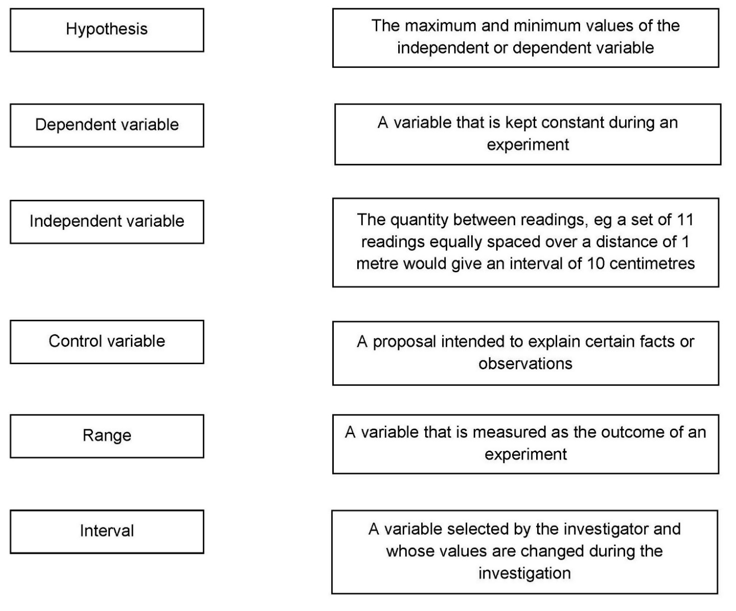

Activity 2 Scientific vocabulary: Making measurements
Link each term on the left to the correct definition on the right.

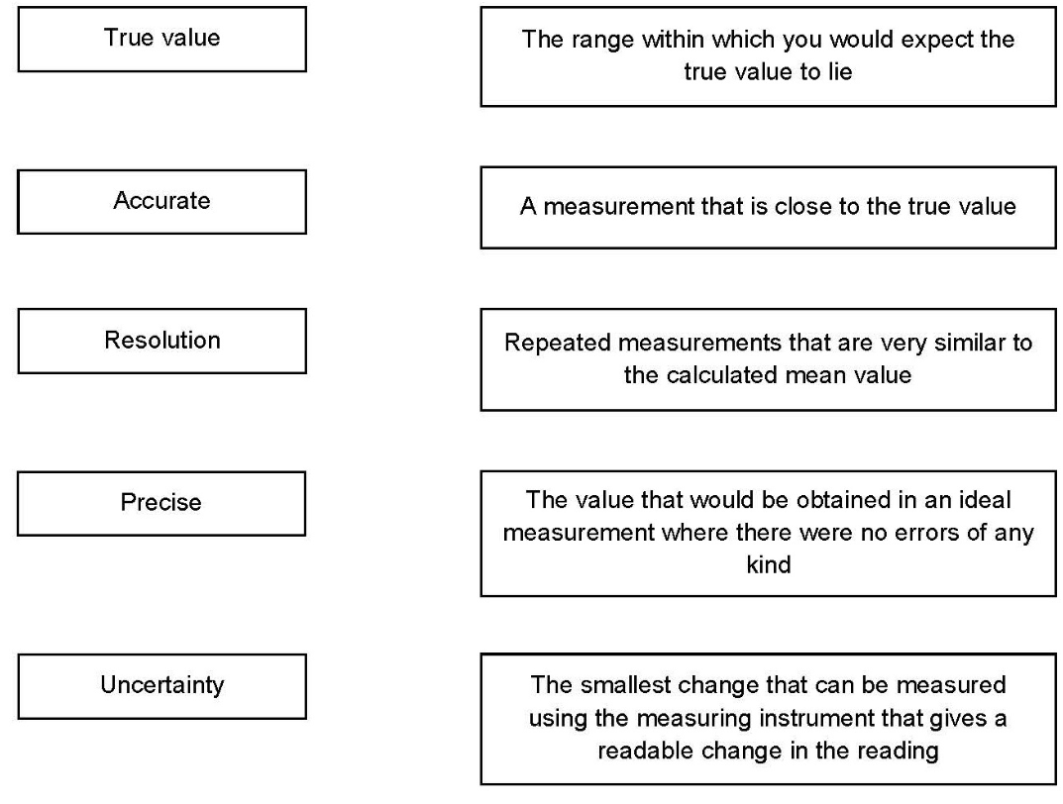

Activity 3 Scientific vocabulary: Errors
Link each term on the left to the correct definition on the right.

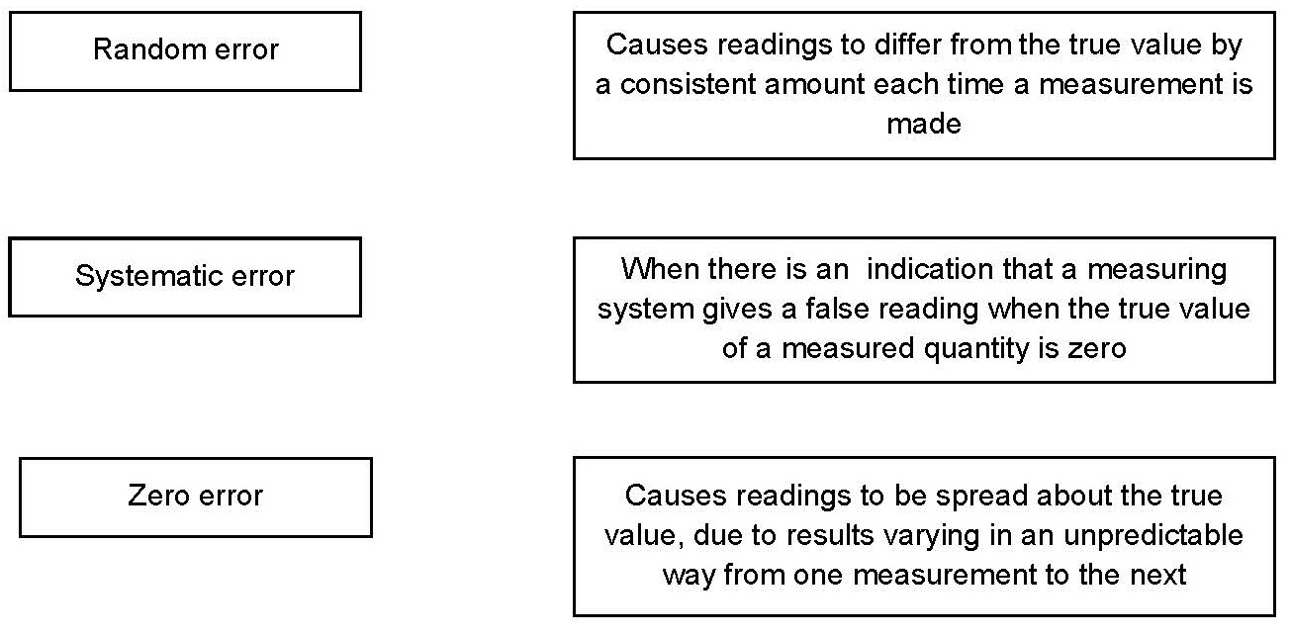

Understanding and using SI units

Every measurement has a size (eg 2.7) and a unit (eg metres or kilograms). Sometimes, there are different units available for the same type of measurement. For example, milligram, gram, kilogram and tonne are all units used for mass.

There is a standard system of units, called the SI units, which are used for most scientific purposes.

These units have all been defined by experiment so that the size of, say, a metre in the UK is the same as a metre in China.

There are seven SI base units, which are given in the table.

Physical quantity | Unit | Abbreviation
Mass | kilogram | kg
Length | metre | m
Time | second | s
Electric current | ampere | A
Temperature | kelvin | K
Amount of substance | mole | mol
luminous intensity | candela | cd

All other units can be derived from the SI base units. For example, area is measured in metres square (written as m²) and speed is measured in metres per second (written as m s^{–1}: not that this is a change from GCSE, where it would be written as m/s).

Using prefixes and powers of ten

Very large and very small numbers can be complicated to work with if written out in full with their SI unit. For example, measuring the width of a hair or the distance from Manchester to London in metres (the SI unit for length) would give numbers with a lot of zeros before or after the decimal point, which would be difficult to work with.

So, we use prefixes that multiply or divide the numbers by different powers of ten to give numbers that are easier to work with. You will be familiar with the prefixes milli (meaning 1/1000), centi (1/100), and kilo (1 × 1000) from millimetres, centimetres and kilometres.

There is a wide range of prefixes. Most of the quantities in scientific contexts will be quoted using the prefixes that are multiples of 1000. For example, we would quote a distance of 33 000 m as
33 km.

The most common prefixes you will encounter are given in the table.

Prefix | Symbol | Power of 10 | Multiplication factor
Tera | T | 10¹² | 1 000 000 000 000
Giga | G | 10⁹ | 1 000 000 000
Mega | M | 10⁶ | 1 000 000
kilo | k | 10³ | 1000
deci | d | 10⁻¹ | 0.1 | 1/10
centi | c | 10⁻² | 0.01 | 1/100
milli | m | 10⁻³ | 0.001 | 1/1000
micro | μ | 10⁻⁶ | 0.000 001 | 1/1 000 000
nano | n | 10⁻⁹ | 0.000 000 001 | 1/1 000 000 000
pico | p | 10⁻¹² | 0.000 000 000 001 | 1/1 000 000 000 000
femto | f | 10^{–15} | 0.000 000 000 000 001 | 1/1 000 000 000 000 000

Activity 4 SI units and prefixes
- What would be the most appropriate unit to use for the following measurements?

- The mass of water in a test tube.
- The volume of water in a burette.
- The time taken for a solution to change colour.
- The radius of a gold atom.
- The number of particles eg atoms in a chemical.
- The temperature of a liquid.

- Re-write the following quantities using the correct SI units.

- 0.5 litres
- 5 minutes
- 20 °C
- 70 °F
- 10 ml (millilitres)
- 5.5 tonnes
- 96.4 microlitres (µl)

- Scientists have been developing the production of a new material through the reaction of two constituents.

Before going to commercial production, the scientists must give their data in the correct SI units.

- The flow rate of the critical chemical was reported as 240 grams per minute at a temperature of 20 °C.
Re-write this flow rate using the correct SI units. Show your working.

Activity 5 Converting data
Re-write the following.

- 0.1 metres in millimetres
- 1 centimetre in millimetres
- 104 micrograms in grams
- 1.1202 kilometres in metres
- 70 decilitres in millilitres
- 70 decilitres in litres
- 10 cm³ in litres
- 2140 pascals in kilopascals

The delta symbol (Δ)

The delta symbol (Δ) is used to mean ‘change in’. You might not have seen this symbol before in your GCSE Chemistry course, although it is used in some equations in GCSE Physics.

Activity 6 Using the delta symbol
In exothermic and endothermic reactions there are energy changes.

The diagram below shows the reaction profile for the reaction between zinc and copper sulfate solution.
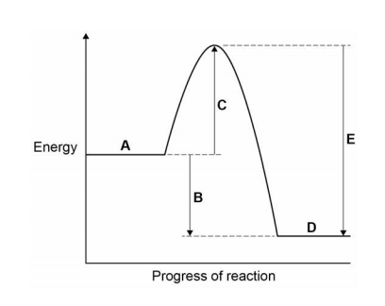
- Which letter represents the products of the reaction?

- Which letter represents the activation energy?

- Complete the sentence using the words below.
The reaction is |  | and therefore ΔH is

endothermic | exothermic | negative | positive

Practical skills

The practical skills you learnt at GCSE will be further developed through the practicals you undertake at A-level. Your teacher will explain in more detail the requirements for practical work in Chemistry.

There is a practical handbook for Chemistry, which has lots of very useful information to support you in developing these important skills. You can download a copy here:

Activity 7 Electrolysis
Students were investigating if the time the current flows through an electrolyte affects the amount of copper deposited on the negative electrode.
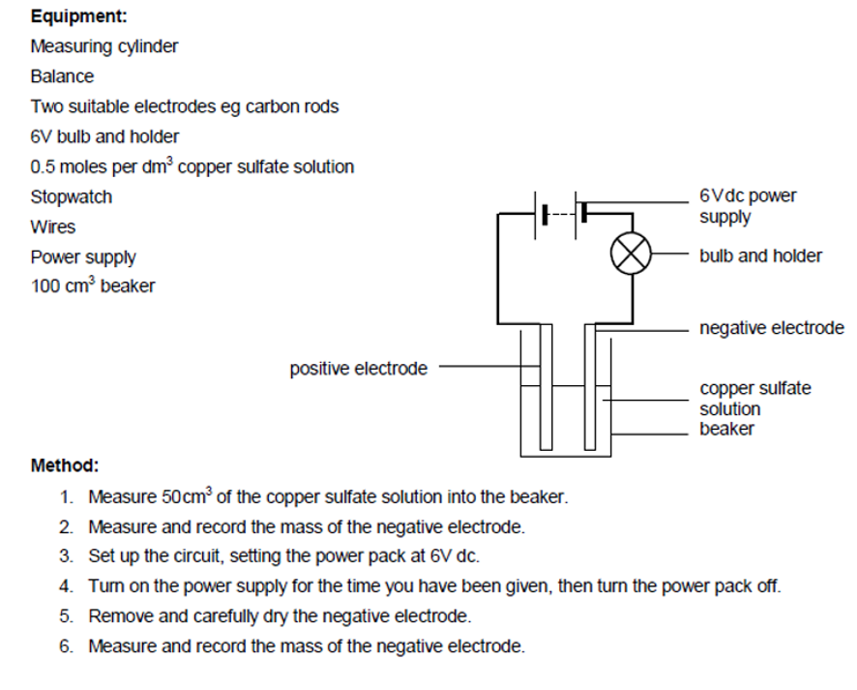
- Write a hypothesis for this investigation.
- What do you predict will be the result of this investigation?
- For this investigation, give
- the independent variable
- the dependent variable
- a control variable.
- What is the difference between repeatable and reproducible results?
- What would be the most likely resolution of the balance you use in a school lab?
- How could you make the reading more precise?
- Random errors cause readings to be spread about the true value.
How could you reduce the effect of random errors and make the results more accurate?
- The results the student recorded are given in the table.
Time / minutes | Increase in mass / g |  |  | Mean
2 | 0.62 | 0.64 | 0.45
4 | 0.87 | 0.83 | 0.86
6 | 0.99 | 1.02 | 0.97
8 | 1.06 | 1.05 | 1.08
10 | 1.10 | 1.12 | 1.10

Calculate the mean increase in mass for each time measurement.

- Plot a graph of your results.

Using maths skills

Throughout your A-level Chemistry course you will need to be able to use maths skills you have developed in your GCSE Chemistry and GCSE maths courses, such as using standard form, rounding correctly and quoting your answer to an appropriate number of significant figures.

Activity 8 Using maths skills
- Write the following numbers in standard form:

- 4000
- 1 000 000

- Zinc oxide can be produced as nanoparticles.

A nanoparticle of zinc oxide is a cube of side 82nm.

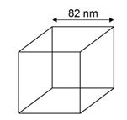

Calculate the surface area of a nanoparticle of zinc oxide. Give your answer in standard form

- Express the following numbers to 3 significant figures:

- 57 658
- 0.045346

- Toothpaste may contain sodium fluoride (NaF).

The concentration of sodium fluoride can be expressed in parts per million (ppm). 1 ppm represents a concentration of 1 mg in every 1 kg of toothpaste.

A 1.00 g sample of toothpaste was found to contain 2.88 × 10^{–5} mol of sodium fluoride.

Calculate the concentration of sodium fluoride, in ppm, for the sample of toothpaste.

Give your answer to 3 significant figures.

Use the following information to help you

To convert moles to grams use g = moles × relative formula mass
Relative formula mass of NaF = 42

Using the periodic table

During your course you will need to become familiar with the periodic table of the elements, and be able to use information from the table to answer questions.

There is a copy of the periodic table that you will be given to use in your exams on the next page.

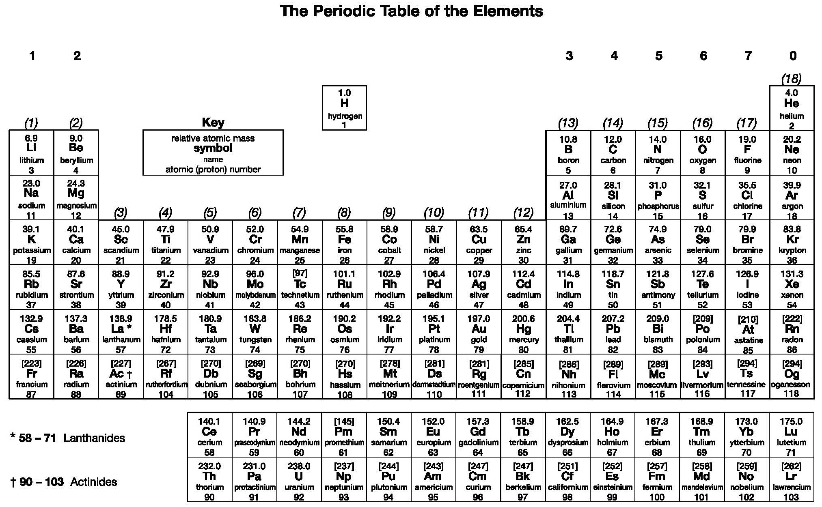

Activity 9 Atoms
- Give the atomic number of:

- Osmium
- Lead
- Sodium
- Chlorine

- Give the relative atomic mass (A_{r}) of:

- Helium
- Francium
- Barium
- Oxygen

- What is the number of neutrons in each of the following elements?
- Fluorine
- Beryllium
- Gold

Activity 10 Formulae of common compounds
State the formulae of the following compounds:

- Methane

- Sulfuric acid

- Potassium manganate (VII)

- Water

Activity 11 Ions and ionic compounds
The table below lists the formulae of some common ions.

Positive ions |  | Negative ions
Name | Formula | Name | Formula
Aluminium | Al³⁺ | Bromide | Br–
Ammonium | NH₄⁺ | Carbonate | CO₃^{2–}
Barium | Ba²⁺ | Chloride | Cl–
Calcium | Ca²⁺ | Fluoride | F–
Copper(II) | Cu²⁺ | Iodide | I–
Hydrogen | H⁺ | Hydroxide | OH–
Iron(II) | Fe²⁺ | Nitrate | NO₃–
Iron(III) | Fe³⁺ | Oxide | O₂–
Lead | Pb²⁺ | Sulfate | SO₄^{2–}
Lithium | Li⁺ | Sulfide | S^{2–}
Magnesium | Mg²⁺
Potassium | K⁺
Silver | Ag⁺
Sodium | Na⁺
Zinc | Zn²⁺

Use the table to state the formulae for the following ionic compounds.

- Magnesium bromide

- Barium oxide

- Zinc chloride

- Ammonium chloride

- Ammonium carbonate

- Aluminium bromide

- Calcium nitrate

- Iron (II) sulfate

- Iron (III) sulfate

Activity 12 Empirical formula
Use the periodic table on page 21 to help you answer these questions.

- The smell of a pineapple is caused by ethyl butanoate.
A sample is known to contain:

0.360 g of carbon
0.060 g of hydrogen
0.160 g of oxygen.

What is the empirical formula of ethyl butyrate?

- What is the empirical formula of a compound containing:

0.479 g of titanium
0.180 g of carbon
0.730 g of oxygen

- A 300g sample of a substance is analysed and found to contain only carbon, hydrogen and oxygen.
The sample contains 145.9 g of carbon and 24.32 g of hydrogen.

What is the empirical formula of the compound?

- Another 300 g sample is known to contain only carbon, hydrogen and oxygen.
The percentage of carbon is found to be exactly the same as the percentage of oxygen.
The percentage of hydrogen is known to be 5.99%.

What is the empirical formula of the compound?

Activity 13 Balancing equations
- Write balanced symbol equations for the following reactions.

You’ll need to use the information on the previous pages to work out the formulae of the compounds.

Remember some of the elements may be diatomic molecules.

- Aluminium + oxygen aluminium oxide

- Methane + oxygen carbon dioxide + water

- Calcium carbonate + hydrochloric acid calcium chloride + water + carbon dioxide

- Chalcopyrite is a sulfide mineral with formula CuFeS₂.

Chalcopyrite is the most important copper ore. It is a sulfide mineral, a member of iron (2+) sulfides and a copper sulfide.

Copper can be produced from rock that contains CuFeS₂ in two stages.

Balance the equations for the two stages in this process.
Hint: remember that sometimes fractions have to be used to balance equations.

Stage 1: CuFeS₂ + O2 + SiO₂ → Cu₂S + Cu₂O + SO₂ + FeSiO →

Stage 2: Cu₂S + CuO → Cu + SO2

Activity 14 Moles
The amount of a substance is measured in moles (the SI unit). The mass of one mole of a substance in grams is numerically equal to the relative formula mass of the substance. One mole of a substance contains the same number of the stated particles, atoms or ions as one mole of any other substance. The number of atoms, molecules or ions in a mole of a given substance is the Avogadro constant. The value of the Avogadro constant is
6.02 × 10²³ per mole.

Complete the table. Use the periodic table on page 21 to help you.

Substance | Mass of substance in grams | Amount in moles | Number of particles
Helium |  |  | 18.12 × 10²³
Chlorine (Cl) | 14.2
Methane |  | 4
Sulfuric acid | 4.905

Activity 15 Isotopes and calculating relative atomic mass
- What is the relative atomic mass of bromine if the two isotopes ⁷⁹Br and ⁸¹Br exist in equal amounts?

- A sample of neon is made up of three isotopes:

²⁰Ne accounts for 90.9%
²¹Ne accounts for 0.3%
²²Ne accounts for 8.8%.

What is the relative atomic mass of neon?
Give your answer to 4 significant figures.

- Copper’s isotopes are ⁶³Cu and ⁶⁵Cu.

If the relative atomic mass of copper is 63.5, what are the relative abundances of these isotopes?

Extended writing

The ability to write coherently in a logical, well-structured way is an essential skill to develop. At GCSE the 6-mark extended response questions are used so students can demonstrate this skill. At A-level you will still need to write precise answers using the correct scientific language.

The command word in a question, like at GCSE, is important as it gives you an indication of what to include in your answers. For example, ‘explain’ means you must give reasons why things are happening, not just give a description. A comparison needs advantages and disadvantages or points for and against.

Activity 16 Types of bonding
Compare the similarities and differences between ionic, covalent and metallic bonding.

