Business Ethics
Development in Jewish Thought
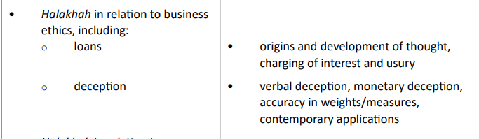

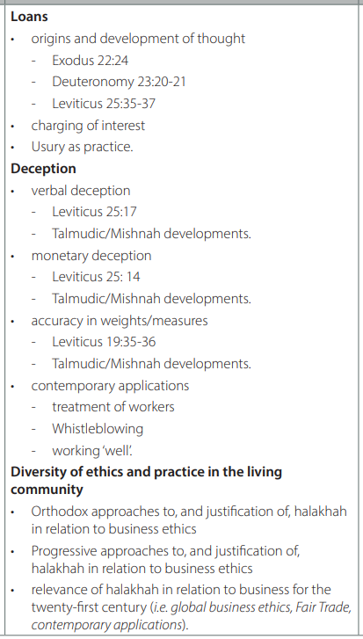

Key quotes
- Exodus 22:22-24
“Do not take advantage of the widow or the fatherless.
If you do and they cry out to me, I will certainly hear their cry.
My anger will be aroused, and I will kill you with the sword;
your wives will become widows and your children fatherless.
- Deuteronomy 23:20-21
You may charge a foreigner interest, but not a fellow Israelite,
so that the Lord your God may bless you in everything you put
your hand to in the land you are entering to possess. If you make
a vow to the Lord your God, do not be slow to pay it, for the
Lord your God will certainly demand it of you and you
will be guilty of sin.
- Leviticus 25:35-37
“‘If any of your fellow Israelites become poor and are unable to support themselves among you, help them as you would a foreigner and stranger, so they can continue to live among you. 36 Do not take interest or any profit from them, but fear your God, so that they may continue to live among you. 37 You must not lend them money at interest or sell them food at a profit.
- Leviticus 25:14
“‘If you sell land to any of your own people or buy land from them, do not take advantage of each other.

Money Lending – Usury

Nosheh – creditor

Texts –
- Exodus 22:24
- Leviticus 25:35-37
- Deuteronomy 23:20-21
Note: numbers 1 and 2 relate to money lending to the poor, but number 3 clearly applies to any moneylending, excluding business dealings with foreigners.

Key terms –
- Neshekh – interest / advanced interest
Why should the Jewish community charge or not charge interest?
- The prosperous should help those less wealthy, if not by gifts, but by free loans.
- Interest and excessive interest was seen to lie at the root of social ruin and was therefore outlawed.
This doesn’t apply to ‘foreigners’. To lend money to foreigners, the main aim was to make money through interest, to lend money to members of the community was to help them out. To help those in need was a moral obligation. Ezekiel talks of usury becoming the gravest of crimes.
Ezekiel 18:11-13:
“He eats at the mountain shrines.
He defiles his neighbour’s wife.
He oppresses the poor and needy.
He commits robbery.
He does not return what he took in pledge.
He looks to the idols.
He does detestable things.
He lends at interest and takes a profit.
Will such a man live? He will not! Because he has done all these detestable things, he is to be put to death; his blood will be on his own head.

Talmud interpretations:
- It is not only the creditor who takes interest who is violating the biblical prohibition, but also the debtor who agrees to pay interest. The guarantor who guarantees the debt that bears interest, the witnesses who attest the creation of an interest-bearing debt and even the scribe who writes out the deed. (BM 5:11; BM 75b; Yad, Malveh 4:2)

Transactions w/non-Jews
- 1179 – Church decreed that the taking of interest was forbidden by Scripture as well as by the laws of nature. All christian usurers would be liable to excommunication.
- As canon law did not apply to Jews, this decree did not prevent them from lending money on interest and moneylending soon became a typically Jewish business.
- Restrictions were put into in the pursuit of any other trade or profession in most countries of Europe.
- From the point of Jewish law, the taking of interest from non-Jews was permitted and the Talmudic restriction that it should not be done unless there were no other means of subsistence was duly held to be compiled with.
- With the renewed change in circumstances, the prohibition on taking interest would apply to Jews and non-Jews alike.
https://www.jewishvirtuallibrary.org/usury

Jewish Moneylending

- Biblical law forbids taking or giving interest ‘to your brother’ (i.e., a fellow Jew).
- This includes money / food or anything.
- The Talmud says that even greeting someone from whom you have borrowed, if such greeting had not previously been the custom, is forbidden.

Jewish Business Ethics

- No specific rules governing economic life.
- Biblical and rabbinic sources of Jewish law and ethics do insist, however, that relations between buyers and sellers, employers and employees and borrowers and lenders should be regulated to prevent the weak from being exploited by the strong, and the uniformed falling prey to the well-informed.
- Work and commerce are not inherently evil or profane.
- It is like other realms of human activity.
- A realm that can be sanctified if you are pure and honest.
- “Let the property of others be as precious in your eyes as your own.” (Rabbinic sage)
- Competition is not disgraceful, but one must take care that no unfair advantage is taken of others who may be economically less powerful or simply less savvy.
- Work has value but has to be honest.

In practice:
- Commerce is to be conducted with honesty and full disclosure of relevant information.
- Transactions at unreasonably high or low prices, unless they meet a particularly stringent standard of disclosure, can be cancelled by the party that has incurred damages.
- Accurate weights and measures are another example on a ban on deceptive practices.
- A balance must take place between the rights of workers and the interests of management.
- One should remain above suspicion and even go beyond the letter of the law – this sanctifies God’s name.

Examples:
- Efforts to reconcile Jewish commercial and labour law and Jewish ethics.
- Differences of opinion.
- Insider trading is out.
- Intellectual property rights are defended in Jewish law, which covers literary works, or recorded music, or video content or even replicate computer software beyond the provisions of the appropriate license.
- Advertising has also been affected by Jewish concepts and values.
- Whistleblowing is encouraged where there is injustice in the work place.

Weights and Measures in Jewish Law

Defective weights and measures are discussed by Maimonides in his Laws of Theft:
“If one weighs with weights that are deficient by the standards agreed upon in his locality, or measures with a measuring vessel deficient by the agreed standards, he violates a negative commandment, for Scripture states (Leviticus 19:35), ‘You shall do no unrighteousness in judgment, in length, in weight, or in measure. (Maimonides, Mishneh Torah, Laws of Theft, 7:1)

Useful reading:
https://bod.org.uk/wp-content/uploads/2021/01/Employers-Guide-to-Judaism2.pdf

