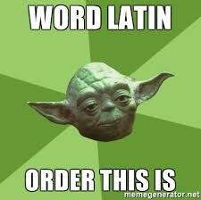

A Level Latin Student Booklet
Congratulations on choosing to study Latin at A Level! We may seem biased, but you have signed yourself up for one of the best A Levels there is. In the words of Libby T in Y12:
“I very almost made the grave mistake of not taking Latin at A-level but came to my senses in the nick of time (phew)! My favourite part of Latin is Prose Composition (translation English into Latin); it’s like doing a massive jigsaw puzzle where the rules change slightly every so often to keep you on your toes, and it’s great fun! At A-level, you get to study your literature texts in a lot more detail and (I think) in a way that feels much more rewarding. You look not only at the language, but at your texts as a whole, and get to properly engage with the larger complexities and concerns of some of the most influential texts ever written. What a joy!”

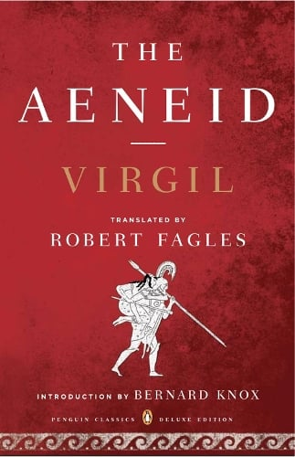
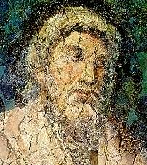
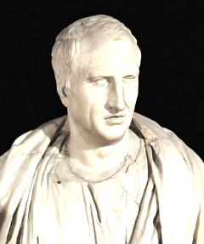
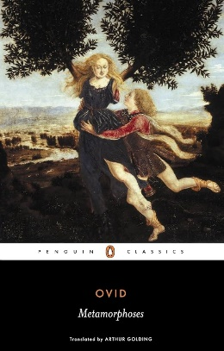
An overview of the A Level Latin course:
Paper 1: Unseen Translation (1 hr 45 mins)  [100 marks] | You have to translate a passage by Livy [prose] into English (50 marks); you then have to translate a passage of Ovid [verse] (45 marks) and scan two lines of verse (5 marks). There is no DVL (Defined Vocabulary List) for this paper.
Paper 2: Prose Composition (1hr 15 mins)  [50 marks] | You will translate a passage of English (c. 100 words) into continuous Latin prose.
Paper 3: Prose Literature  (2 hrs)  [75 marks] | Year 12: Cicero pro Roscio (Chapters 5-29).  Year 13: Apuleius Metamorphoses (Book VI, 7-21 in Latin; Book V, 28-31, Book VI, 1-6, 21-24 in English).
Paper 4: Verse Literature  (2 hrs)  [75 marks] | Year 12: Ovid Metamorphoses VII, lines 1-227 in Latin; you will also study all of Book 7 in English translation.  Year 13: Virgil Aeneid IV (lines 1-128, 529-629).

Here are some tasks to complete before returning to school in September. Completing the ‘definitely’ tasks will put you in an excellent position for the A Level course. No judgement will be cast on whether you complete the ‘suggested’ or ‘feeling inspired’ tasks, but they will hopefully pique your interest in what’s to come!
From Ms Haye:
I will be teaching you Paper 1 (unseen translation) and Paper 4 (verse literature).
- Definitely: read Ovid Metamorphoses Book 7 (Penguin copy available in school library or visit https://www.poetryintranslation.com/PITBR/Latin/Metamorph7.php)
- Definitely: revise GCSE DVL (Defined Vocabulary List)
- Suggested: Listen to ‘Natalie Haynes Stands Up for the Classics’ episode on Ovid https://www.bbc.co.uk/programmes/b07756bd (also on Spotify)
- Suggested: (re)read Medea by Euripides and/or rent the National Theatre’s production from 2015 https://www.ntathome.com/checkout/medea/purchase (this is a different version/section of the story of Medea from your A Level set text, but still interesting and useful!)
- If you’re feeling inspired: written/visual response (choose one)
- Mythical Podcast Episode Script and (optionally) record a 5 minute podcast episode as if you’re reporting for a true-crime or mythological gossip show. You could explore Medea’s actions, reputation, and how ancient audiences might have received her story—perhaps with a “hot take” segment from other characters.
- Visual Mood Board - Create a visual mood board that captures the atmosphere, themes, and emotional trajectory of the Medea episode using magazine clippings, sketches, or digital collages.
Tasks for Ms Jamison:
I will be teaching you Paper 2 (prose composition) and Paper 3 (prose literature).
- Definitely: read Imperium by Robert Harris which gives a fictionalised run through the early years of Cicero’s life (our first prose author) (https://www.waterstones.com/book/imperium/robert-harris/9780099527664 - also great as an Audiobook)
- Definitely: listen to at least one podcast about Cicero (all on Spotify or other podcast streaming apps):
  - ‘The rise of Cicero’, The Ancients
  - ‘Cicero’, Natalie Haynes Stands up for the Classics
  - ‘Cicero’, In Our Time
- Suggested: revise GCSE word list (including all principle parts) and grammar (syntax and accidence)
- Suggested: read The Roman Republic: A Very Short Introduction (D. M. Gwynn) - https://www.waterstones.com/book/the-roman-republic/david-m-gwynn/9780199595112
- If you’re feeling inspired and don’t mind some time in front of the TV/laptop:
- Watch Timewatch’s Murder in Rome, a short documentary produced for the BBC in 2005 featuring a dramatization of the pro Roscio (the speech we’re studying – would highly recommend this video!): https://archive.org/details/time-watch-murder-in-rome-2005
- Watch HBO’s gritty, violent (and at times explicit) drama, Rome (2005-7) which interweaves fictional characters and storylines with historical characters and events, following the life of Julius Caesar and the fall of the Roman Republic.
If you have any questions about the course over the summer holidays, please drop Ms Jamison an email. We hope you have a wonderful break and see you on GCSE Results Day!

