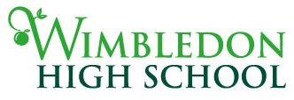
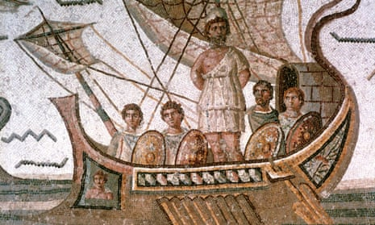

A Level Classical Civilisation

We are very pleased that you have decided to take up Classical Civilisation at A Level – it is a subject that is truly interdisciplinary, covering literature, history and philosophy.

Overview of the A Level Classical Civilisation syllabus:
A Level Classical Civilisation consists of three exams. [The marks for each paper are shown in brackets]:
[01] The World of the Hero [100] | You will study two great epic poems:  (a) Year 12: Homer’s Odyssey  [Context Books: 1, 5 – 13, 16 – 19 & 21 – 23]  (b) Year 13: Virgil’s Aeneid  [Context Books: 1, 2, 4 & 6 – 12]
[02] Greek Theatre [75] | In Year 12, you will study three renowned Greek plays:  Sophocles Oedipus the King  Euripides Bacchae  Aristophanes Frogs  as well as visual sources and contextual material.
[03] Love & Relationships [75] | In Year 13, you will study works by the archaic Greek lyric poet Sappho, the philosopher Plato, the Roman poet Ovid and the Stoic philosopher Seneca. You will consider questions such as: What are the ideal qualities (& relative status) of men & women? What makes a good marriage? Should adultery be tolerated? How should we define ‘love’? What is the difference between love and desire? Can (or should) desire be resisted or controlled?

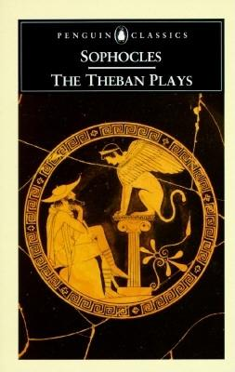
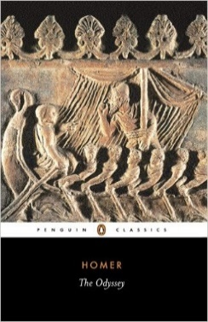
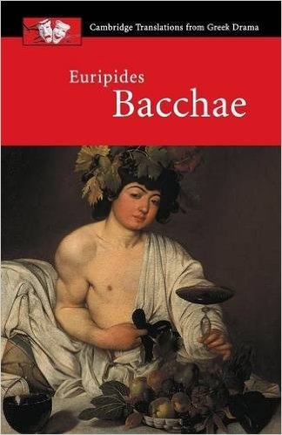
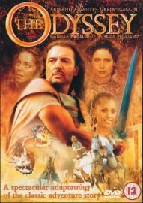
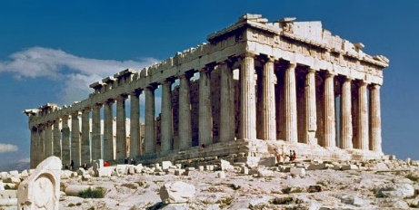

Here are some tasks to complete before returning to school in September. Completing the ‘encouraged’ tasks will put you in an excellent position for the A Level course. No judgement will be cast on whether you complete the ‘suggested’ or ‘feeling inspired’ tasks, but they will hopefully pique your interest in what’s to come!

Books to buy:
1. Homer’s Odyssey, translated by E. V. Rieu, revised by D. C. H. Rieu (Penguin Classics)
2. The World of the Hero Sally Knights (OCR/Bloomsbury)
3. Sophocles The Theban Plays, translated by R. Fagles (Penguin Classics)
4. Euripides Bacchae, Cambridge Translations from Greek Drama (ed. D. Franklin, C. U. P.)
5. Aristophanes Frogs, Cambridge Translations from Greek Drama (ed. J. Affleck & C. Letchford, C. U. P.)

From Ms Haye:
I will be teaching you Paper 1 (The World of the Hero).
- Encouraged – read Odyssey Book 1-5 in English.
- Encouraged – read one novel connected to or inspired by the Odyssey (ideas below, but there are many more out there). Come ready to share a review of your book.
  - The Penelopiad by Margaret Atwood
  - Women of Troy series by Pat Barker (especially The Voyage Home)
  - Circe by Madeline Miller
- Suggested – read the rest of the Odyssey in English
- Suggested – watch Christopher Nolan’s ‘Odyssey’ in the cinema!
- Suggested – listen to Natalie Haynes’ Stand up for the Classics episode on ‘The Odyssey’
- If you’re feeling inspired – read a 'Very Short Introduction' to a Classical subject - eg 'Very Short Introduction to Classics/ Classical Literature/ Classical Mythology

From Ms McLaughlin
I will be teaching you Paper 2 (Greek Theatre) and Paper 3 (Love & Relationships).
- Encouraged – Read a novel based on a Greek tragedy, such as:
  - The Children of Jocasta by Natalie Haynes
  - Amber Fury by Natalie Haynes
  - The Furies by Natalie Haynes
- Encouraged – Listen to Natalie Haynes’ Stand up for the Classics’ episode on Sophocles
- Suggested – read Sophocles Oedipus Rex (Penguin translation)
- Suggested – visit Room 14 at the British Museum to locate and photograph any Greek vases depicting Greek mythology and/or tragedy
- Suggested – explore the National Theatre introductory videos about Greek Theatre: https://www.nationaltheatre.org.uk/learn-explore/greek-theatre-video-collection/
- If you’re feeling inspired – Read Greek Tragedy: An Introduction by Marian Baldock

If you have any questions about the course over the summer holidays, please drop Ms Jamison an email. We hope you have a wonderful break and see you on GCSE Results Day!

