
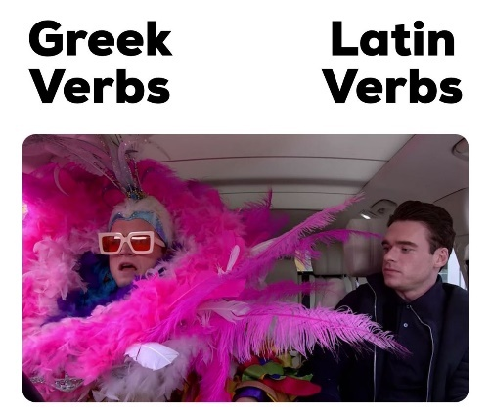

A Level Classical Greek

We are very pleased that you have decided to continue with Greek at A Level – it is one of the most rigorous, yet fascinating and fun, subjects on offer in the Sixth Form.
Heather L in Y13 says:
“As someone whose favourite GCSE was Greek - I only came to love it more at A Level due to the additional types of literature and language I can study. From the ability to scan texts for rhythm to writing from English to classical Greek, the A Level course gives you a perfect experience with a broader knowledge of antiquity – aided by the wide range of classical texts studied (from political and historical writing to satirical and tragic).”

Overview of the A Level Greek syllabus:
A Level Classical Greek consists of four exams. [The marks for each paper are shown in brackets]:
[01] Unseen Translation (1-¾ hours) [100]: | You have to translate a passage by Xenophon [prose] into English (50 marks); you then translate a passage of Euripides [verse] (45 marks) and scan two lines of verse (5 marks).
[02] Prose Composition (1-¼ hours) [50]: | You will translate a passage of English (c. 100 words) into continuous Greek prose.
[03] Prose Literature (2 hours) [75]: | Y12: Plato Crito: 43a to 48d in Greek; 43a to end in English.  Y13: Plato Crito: 48d to end in Greek.
[04] Verse Literature (2 hours) [75]: | Y12: Homer Odyssey XXII lines 1-238 in Greek & all of Book XXI and rest of book XXII in English.  Y13: Sophocles Electra lines 1-85 and 254-416.

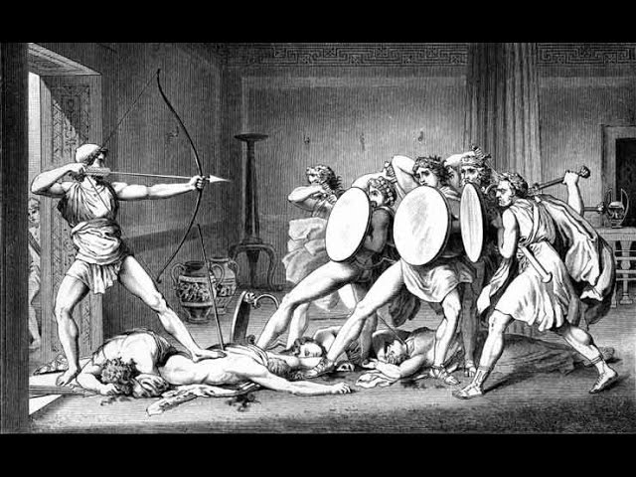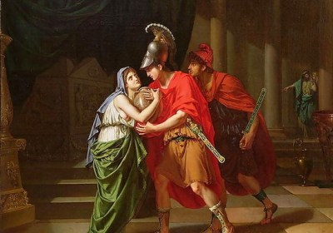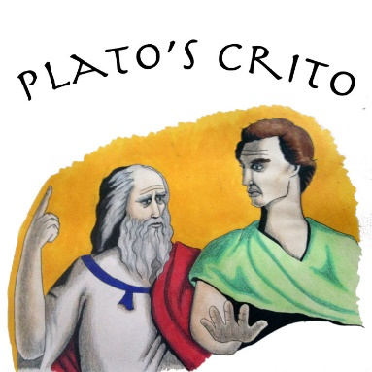

Here are some tasks to complete before returning to school in September. Completing the ‘encourgaed’ tasks will put you in an excellent position for the A Level course. No judgement will be cast on whether you complete the ‘suggested’ or ‘feeling inspired’ tasks, but they will hopefully pique your interest in what’s to come!

From Mr Wilmore:
I will be teaching you Paper 1 (unseen translation) and Paper 4 (verse literature).

- Encouraged – read Homer’s Odyssey Book 22 in English (I recommend Emily Wilson's translation) and choose 10 quotations that you feel are important to the plot/characterisation (have these ready for Sept and be prepared to defend them!).
- Encouraged – read one novel connected to or inspired by the Odyssey (ideas below, but there are many more out there). Come ready to share a review of your book.
  - The Penelopiad by Margaret Atwood
  - Women of Troy series by Pat Barker (especially The Voyage Home)
  - Circe by Madeline Miller
- Suggested – read the rest of the Odyssey in English (as our set text is near the end of the Odyssey, it would be great to know where it comes in the story!)
- Suggested – listen to Natalie Haynes’ Stand up for the Classics episode on ‘The Odyssey’
- If you’re feeling inspired – read a 'Very Short Introduction' to a Classical subject - e.g. 'Very Short Introduction to Classics/ Classical Literature/ Classical Mythology

From Ms Jamison:
I will be teaching you Paper 2 (prose composition) and Paper 3 (prose literature).
Look out for an email from me linking you to all the resources mentioned below!
- Encouraged – Revise the GCSE DVL from English into Greek
- Encouraged – Read Plato’s Apology (the work which precedes and contextualises our set text) or listen to the adapted version, and answer the questions provided
- Suggested – Read ‘Plato for beginners’ 1-3
- Suggested – Watch Bettany Hughes’s documentary ‘Genius of the Ancient World – Socrates’
- Suggested – Read Plato’s Euthyphro, to find out more about Socrates’ trial, and to get a flavour of his dialectic style
- If you’re feeling inspired – Keep reading ‘Plato for beginners’ and, when you come across a dialogue which piques your interest, give it a google and have a read!

If you have any questions about the course over the summer holidays, please drop Ms Jamison an email. We hope you have a wonderful break and see you on GCSE Results Day!

