Yr 12 Product Design Summer Task
Your Task
- In Year 12 whilst studying A Level Product Design you will investigate polymers, woods, metals, and papers & boards in depth.
- We would like you to begin your investigations by collecting and identifying as many different materials from the list below as possible. We are asking you to display them in a creative and portable way; you need to be able to bring your collection along to lessons easily.
- Samples of the real material would be wonderful, but you could also uses sketches and images to convey them.
- With each material we would like you to highlight its classification (eg thermos forming or thermosetting), its physical and mechanical properties as well as some typical uses.
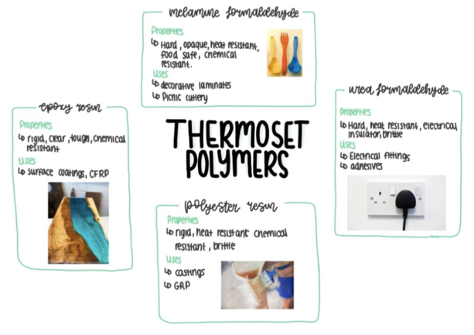
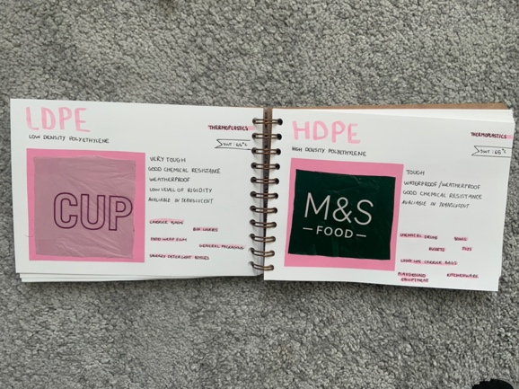
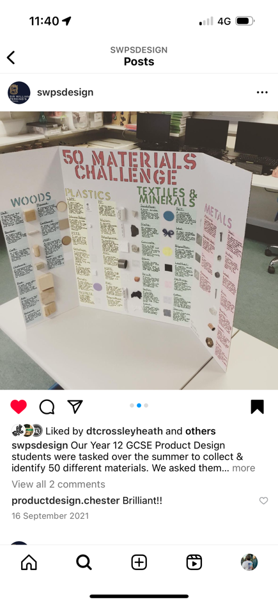
Materials List
Papers & Boards | Woods
Layout paper  Cartridge paper  Tracing paper  Bleed-proof paper  Treated paper  Watercolour paper  Corrugated card  Bleached card  Mount board  Duplex card  Foil backed and laminated card  Metal effect card  Moulded paper pulp | Oak  Ash  Mahogany  Teak  Birch  Beech  Pine  Spruce  Douglas fir  Larch  Cedar  Plywood  Marine plywood  Aeroply  Flexi ply  Chipboard  MDF
Metals | Polymers
Aluminium  Copper  Zinc  Silver  Gold  Titanium  Tin  Low carbon steel  Medium carbon steel  Cast iron  Stainless steel  High speed steel  Die steel  Bronze  Brass  Duralumin  Pewter | Low density polyethylene LDPE  High density polyethylene HDPE  Polypropylene PP  High impact polystyrene HIPS  Acrylonitrile butadiene styrene ABS  Polymethacrylate PMMA  Nylon  Rigid polyvinyl chloride uPVC  Flexible polyvinyl chloride PVC  Urea formaldehyde UF  Melamine formaldehyde MF  Polyester resin  Epoxy resin

Properties List
Mechanical Properties | Physical Properties
Properties associated with how a material reacts to an external force. | Properties associated with the actual makeup of or structure of the material.
Compressive strength  Tensile strength  Bending strength  Shear strength  Torsional strength  Hardness  Toughness  Plasticity  Ductility  Malleability  Elasticity | Electrical conductor  Electrical insulator  Thermal conductor  Thermal insulator  Thermal expansion  Opaque  Translucent  Transparent  Density  Fusibility  Magnetic  Corrosion/degradation resistant
Other Properties
Aesthetics
Cost
Texture

