Economics Holiday Homework – Year 11
21/06/24
Task 1 – Macroeconomics

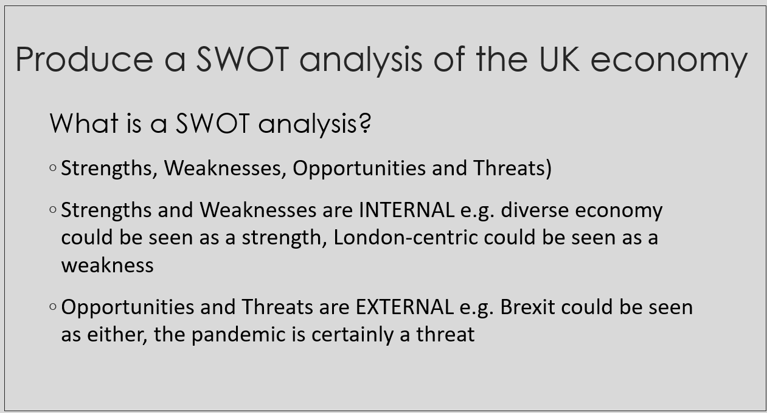
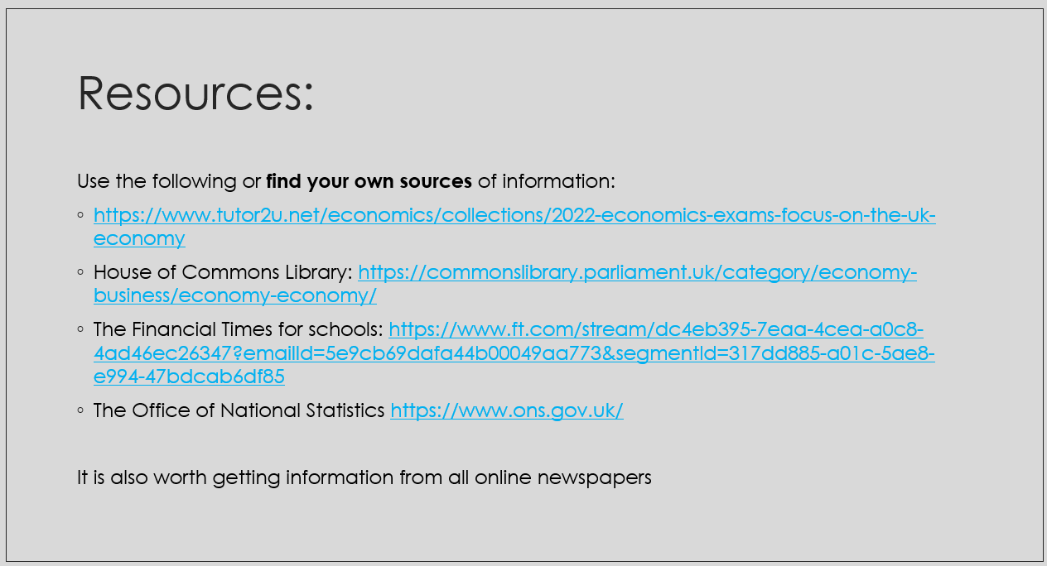

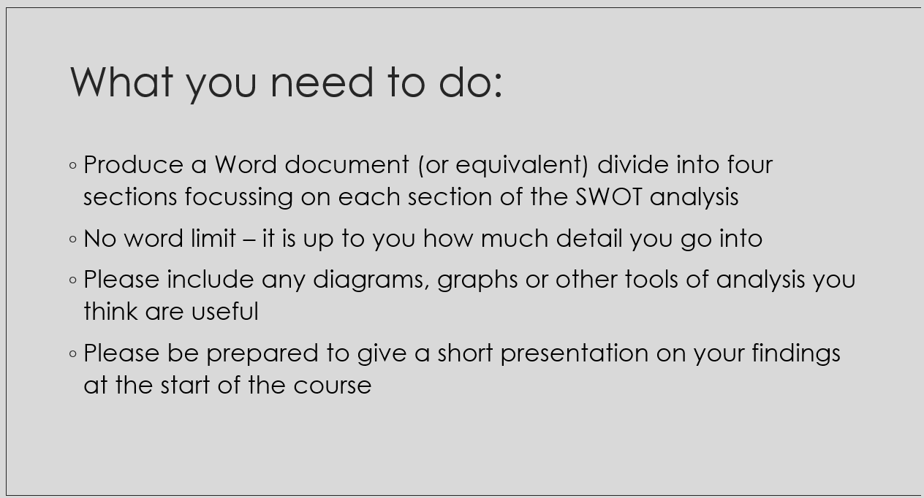

Task 2 – Microeconomics
Company SWOT (strengths, weaknesses, opportunities and threats) analysis
Choose one of the following industries: house building, car production, supermarket, technology, mining, music, film, advertising, banking.
Research and produce an SWOT analysis (as you did for task 1) for a company of your choice within your chosen industry.
Please produce your SWOT electronically, either PPT, Prezi or any other suitable software.
Start with company background: year founded, logo, number of shops, current CEO, revenue, profit, employees and main competitors.
Example SWOT… (for Apple Inc.)
Strengths:
- Brand awareness and reputation – explain how well recognised the brand is e.g. value of the brand.
- Sound financial performance with one of the strongest cash flows – explain
Weaknesses:
- Overdependence on iPhone sales
- Weak distribution channels in India
Opportunities:
- Health-related wearable gadgets could be introduced to the market
- Expanding mobile payments market
Threats
- Intensifying competition puts pressure on Apple’s market share, revenue and profits
- Lawsuits over patent infringements resulting in damaged brand reputation

Make sure you explain each of factor within each section of the SWOT. Use data where possible to back up your reasons.
You don’t need to go into huge depth for either of these tasks – we just want you to get a brief overview of some of the challenges and opportunities facing the UK economy and companies operating within it.
You will not be expected to present your findings, but we will use your work as the basis for class discussion.

Good luck!

