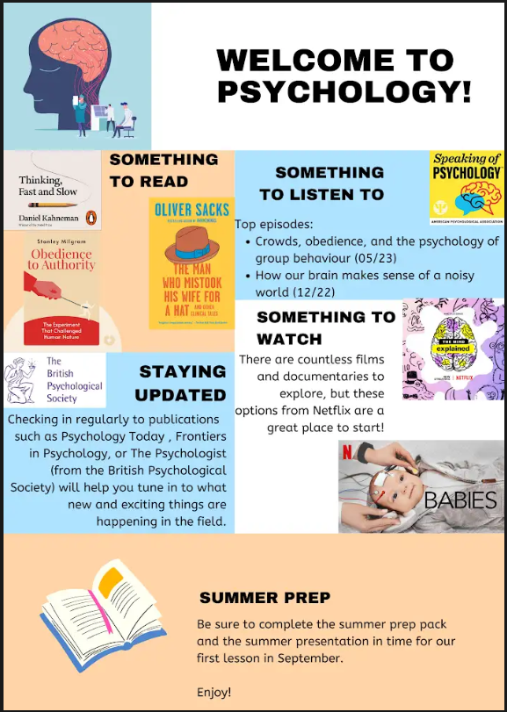A **huge welcome** to Psychology. The study of Psychology will be very new to the majority of you, but it will open new and exciting areas of exploration and different ways of thinking about why people do the things that they do. It is important to read and complete this booklet in order to gain an overall picture of what Psychology is all about.

The booklet contains tasks for you to complete that will help you to build knowledge and understanding of key components within the Psychology A- Level. You will start to find psychological concepts and theories cropping up in all aspects of life, as the subject is a hugely useful and applicable science. There will be reference to it in your favourite TV programmes, your summer read, the news, social media posts and more! On the right, you will find some optional additional reading/watching/listening that you may wish to explore over summer. Read on to learn more about Psychology and complete all tasks in the pack for the first lesson in September. Enjoy!

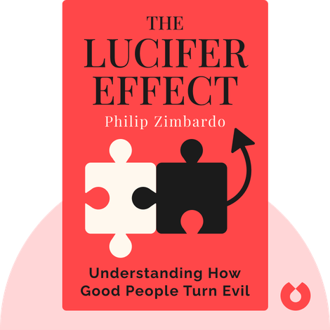

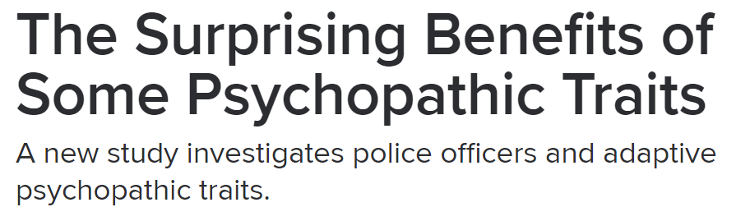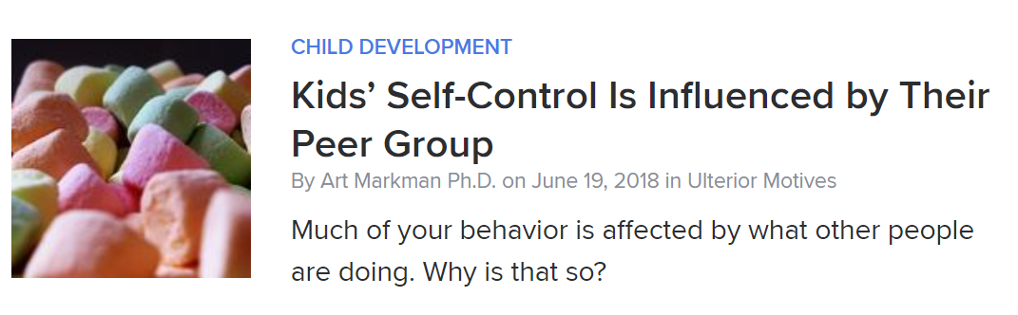

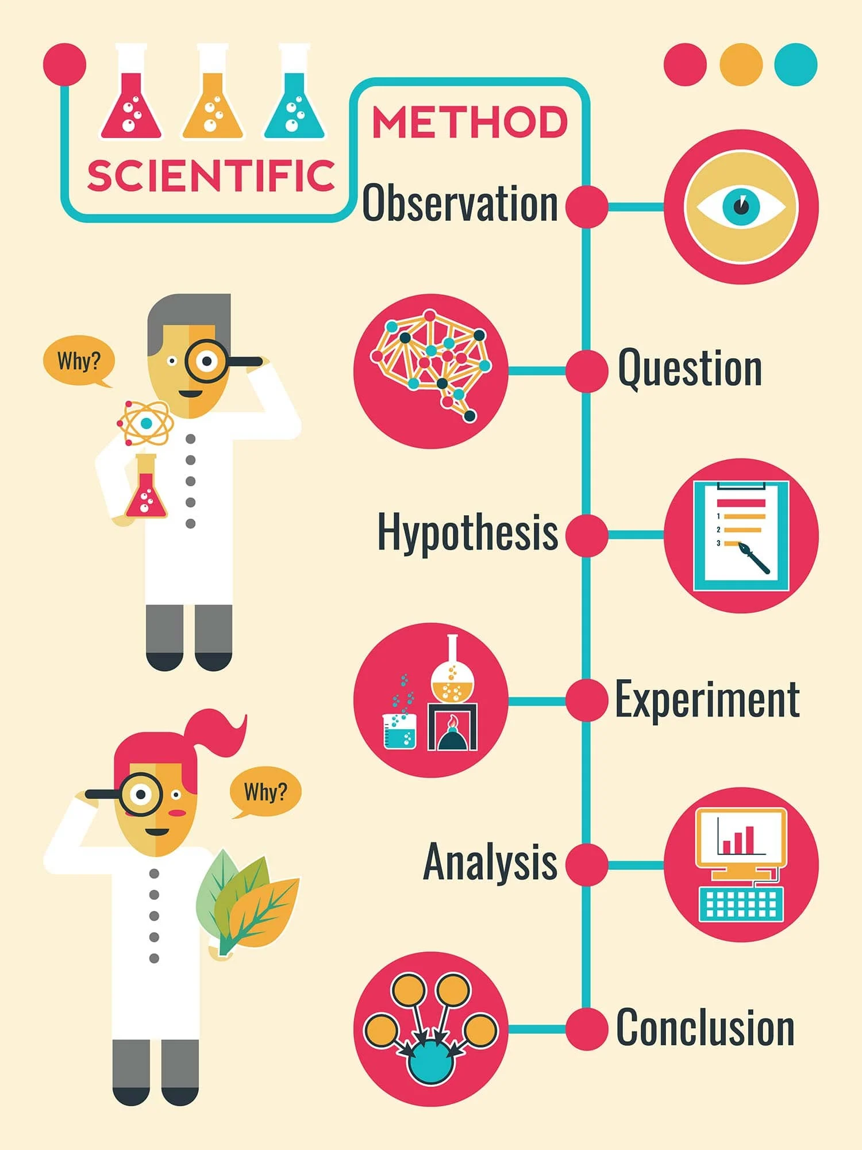

First and foremost, Psychology is the **scientific** study of the brain and behaviour. Psychologists want their ideas/theories to be:

· Tested and agreed with by other people.

· Applicable to lots of people all over the world.

· Useful and beneficial to others.

Because we often investigate things we cannot physically see (memories, dreams, fears, plans, love), psychologists have to be very careful when planning their investigations. Psychologists use a range of ways to carry out scientific investigations; these are known as research methods.

We look at four research methods:

1. Experiment

· Usually has an independent variable and dependent variable and attempts to establish cause and effect.

· Can manipulate one variable and keep everything else the same through control measures.

· Allocate participants into groups.

· If the groups behave differently then you know it’s the thing you have manipulated (IV) that caused the different result (DV), as everything else was kept the same.

2. Self-report

· Can ask people how they think and behave.

· Can conduct interviews or fill in questionnaires.

· Psychologists collect the data and make conclusions about how people think and behave.

3. Observation

· Can watch how they behave.

· Focus on their observable behaviour.

· Gather data and make conclusions based only on what you can observe.

4. Correlation

· Sometimes it is unethical to split people into different groups and treat them differently (*purposefully neglect a group of children*).

· Sometimes it is impractical or impossible to manipulate the variables (*make one group rich and one group poor*).

· Sometimes all we can do is measure two characteristics in a group and see if there is a relationship between the two.

**Let’s put the research methods into action**

Research aim: I want to know whether the temperature of a room affects people’s ability to concentrate. To study this, I could use:

Experiment

· Split people into two groups and put one in a hot and one in a cold room. Give them both the same word search puzzle test and see who gets the highest score.

Self-report

· Ask people to rate from 1-10 how hard they find it to concentrate on a warm or a cold day.

Observation

· Go to different libraries, record how warm it is, and observe how many books people read/how distracted they get/how long they stay for.

Correlations

· Find the average GCSE results and average temperatures for different regions and see if they are related.

**Research focus: Does sleep affect your learning?**

**Explain how you would design the following to study whether sleep affects your learning:**

**1. Experiment**

**2. Self-report**

**3. Observation**

**4. Correlations**

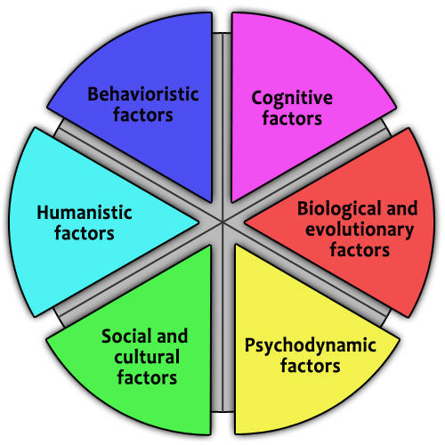

There are also many different ways people see behaviour and therefore many different explanations for why we do the things we do. In Psychology we look at 6 approaches, these are different viewpoints that psychologists believe can explain people’s behaviour.

**The Nature / Nurture Debate**

This debate is very important in Psychology. It debates how important the two influences of nature and nurture are in explaining human behaviour.

· Nature = Inherited influences such as our genes and physiology

· Nurture = How life has influenced us through our experiences

**Where do you stand on the nature / nurture debate?**

1. **Are people born clever (nature) or do they become clever through hard work / good teaching (nurture)? Explain one reason for your view.**
2. **Are criminals born with a tendency to commit crime (nature) or do they commit crime because they have had a difficult upbringing (nurture)? Explain one reason for your view.**

Is your brain plastic?

Flexing your muscles may make them bigger. Is the same true for your brain? Eleanor Maguire (a neuroscientist at UCL) wanted to see if your job can actually affect the size of parts of your brain.

She investigated whether the size of a specific area of the brain (the hippocampus) would be different in London black cab drivers. She wanted to find out if it is possible for the brain to adapt itself according to the circumstances, in this case, to navigate around London.

Using MRI scans, she found that the taxi drivers had a significantly larger volume in one part of the hippocampus compared to a control group of Londoners.<https://www.youtube.com/watch?v=sfy9j0h9_O8>

1. **Name two methods of scanning the brain.**

1. **Explain the purpose of having control groups in psychological research.**

How difficult is it to tell the ‘sane’ from the ‘insane’?

David Rosenhan was a psychiatrist who investigated the question: Can we tell the sane from the insane? He asked 8 sane people to telephone the hospital for an appointment, and turn up complaining of hearing voices. They were all admitted to the psychiatric ward. Straightaway all 8 no longer faked these symptoms. They were told they would have to get out of the hospital by convincing staff they were sane.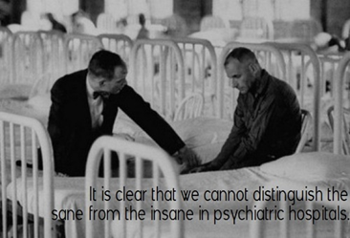

Staff at the hospitals were surprised at the results because they had doubted that sane people could be admitted to their hospital. Rosenhan showed that there is a great overlap between normal and abnormal behaviour, but once someone has been labelled as mentally ill, behaviour is interpreted differently.

<https://www.youtube.com/watch?v=D8OxdGV_7lo>

1. **The research method used by Rosenhan was a field experiment. Name the two other types of experiment which are used in Psychology?**
2. **Name one psychotic disorder.**
3. **Define the term ‘ecological validity’.**

Conformity to roles 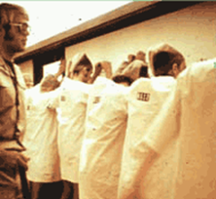

In 1971, psychologist [Philip Zimbardo](http://psychology.about.com/od/profilesmz/p/philip-zimbardo.htm) and his colleagues set out to create an experiment that looked at the impact of becoming a prisoner or prison guard. Zimbardo and his researchers set up a mock prison in the basement of Stanford University's psychology building, and then selected 24 students to play the roles of both prisoners and guards. The participants were selected from a larger group of 70 volunteers because they had no criminal background, lacked psychological issues and had no major medical conditions. The volunteers agreed to participate for a one- to two-week period in exchange for $15 a day.

The fake (simulated) prison included three 6 x 9 foot prison cells. Each cell held 3 prisoners and included 3 beds. Other rooms across from the cells were used by the prison guards and warden. One very small space was designated as the solitary confinement room, and another small room served as the prison yard.

The 24 volunteers were randomly assigned to being either a prisoner or a guard. Prisoners were to remain in the mock prison 24-hours a day for the whole length of the study. Guards had to work in teams of 3 for 8 hour shifts. After each shift, guards were allowed to return to their homes until their next shift. Researchers were able to observe the behaviour of the prisoners and guards using hidden cameras and microphones.

While the Stanford Prison Experiment was originally going to last 14 days, it had to be stopped after just 6 days due to what was happening to the students. The guards were abusive and the prisoners began to show signs of extreme stress and anxiety.

While the prisoners and guards were allowed to interact in any way they wanted, the interactions were generally hostile. The guards began to behave in ways that were aggressive and abusive toward the prisoners, while the prisoners became depressed. Five of the prisoners began to experience such severe negative emotions, including crying, that they had to be released from the fake prison early.

* + - 1. **Suggest one way in which this research could be improved and explain why your suggestion improves it.**

**One of the most important parts of your summer prep is centred on exploration and fostering curiosity about Psychology.**

Here are some ideas you might like to explore…

· **Cross Cultural Research**

There are many human behaviours which have been studied cross-culturally. Can you find examples of similarities and differences in behaviours between cultures to demonstrate which behaviours are universal, and therefore are probably biological in nature, rather than socially constructed? 

· **Neuroscience**

One aspect of neuroscience not covered by the lecture is the difference in teenager’s “reward systems” in the brain. What are reward systems; what are the differences in teen reward systems; and what sort of behaviours can the results of these differences be seen in? The Stanford marshmallow experiment and its follow-up could be a good place to start.

· **Social Identity**

What are the different ways in which teenagers seek to express their own identities? From becoming vegan and protesting about politics, to fashion, tattoos and piercings; what does research show us about the psychology behind these modes of expression?

· **Relationships**

What is the biological psychology behind infatuation and love? Can love be measured in the form of biological signs and symptoms? How are hormones and neuroscience related to the experience of love? Is love universal or a social construct?

· **The Psychology of Personality**

Other than the MBTI there are many other models of personality (such as The Big 5) as well as theories for how personality develops. You could research one or more of these and present on how it is used, as well as evaluating it for its uses, pros and cons.

· **Atypical Psychology** 

As well as pre-existing neurodevelopmental disorders which change their expression in adolescence, the teen years are also a peak time for the onset of other psychological disorders. What sort of disorders do teenagers often develop and what are the reasons this may be? You could take a broad look at a range of disorders or take a deep dive into one.

**Presentation Format**

The presentation should be aimed at your peers who may have no prior knowledge on the topic you have picked. The choice is yours for how you actually present, for example:

• a conventional PowerPoint/ Google Slides presentation (if you download the Pear Deck you can add interactive slides to your Google Slides presentation for audience participation).

• a lecture or speech.

• a seminar (teaching the class / discussion from excerpts or data)

**There will be a ‘live’ question and answer session at the end of the presentation.**

The presentation is to show me what you have found and discovered about your topic area. Each of you will complete this ‘live’ presentation, ideally covering:

• what your project is about, its background and context

• the reasoning that underpins your chosen direction for your research

• the specific title you have chosen

• your aims and objectives, what you wanted to find out

• the main body of your findings.

**You should expect to spend around 3-4 hours on this and it should be ready for the first lesson in September!**