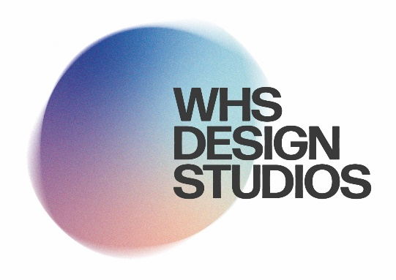A Level - Fashion & Textiles

Summer work

**• Paul Poiret • Chanel • Dior • Mary Quant • Yves St Laurent • Pierre Cardin • Vivienne Westwood • McQueen.**

**• Art Nouveau • Art Deco • Pop-art • Minimalism • Punk.**

Welcome to your summer work for the transition to Year 12! I am thrilled to embark on this creative journey with you. The summer break provides a valuable opportunity for you to delve into the world of textiles and expand your knowledge and understanding of design, style, and influential movements.

For this summer project, you will be tasked with creating two designer research boards and one design styles and movement research board. These boards will serve as a visual representation of your exploration and findings. They will showcase your ability to analyse and appreciate the work of renowned designers, as well as your understanding of the impact of design styles and movements on the world of textiles.

Your first task is to select two designers from the provided list. You will then need to research and gather information about their backgrounds, inspirations, design processes, and notable works. Explore their use of materials, techniques, and the concepts they explore through their creations. Your aim is to gain a comprehensive understanding of their unique design language and aesthetic.

Next, you will create a design styles and movement research board. This board will allow you to delve into the broader context of textile design. Investigate various design styles and movements that have shaped the industry throughout history and continue to influence contemporary practices. Research how these movements emerged, the key characteristics of their design philosophies, and the impact they had on textiles and fashion.

During the first lesson in Year 12, you will present your findings to the class. This presentation should effectively communicate the essence of each designer's work and the significant design styles and movements you have researched. Consider using visual aids, sketches, fabric swatches, and any other relevant materials to enhance your presentation and bring your research to life.

Remember, this summer work is designed to foster your passion for textiles and encourage you to develop a critical eye for design. I encourage you to approach this project with curiosity, creativity, and attention to detail. Use this time to explore, experiment, and broaden your horizons as budding textile designers.

I am excited to see your progress and witness the depth of your research during our first lesson in Year 12. Have a fantastic summer and remember to enjoy the process of discovering and appreciating the vast world of textiles!

Turn over for examples

Examples

