**Using algebra to look at properties of number**

***These questions are all related to the notation you discover in 1a) – so check this first***

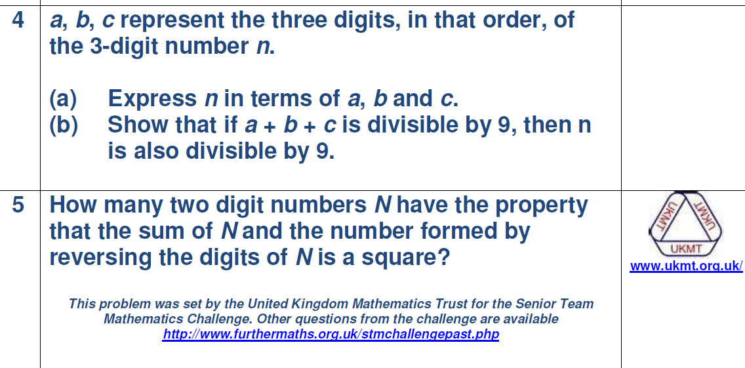



Prove the divisibility test for 9. i.e if the sum of the digits of a 4 digit number are divisible by 9 then the number is divisible by 9.



