**A Level Mathematics - Statistics**

**Data Set**

Pearson have provided a large data set, which will support the assessment of Statistics in the A level Mathematics Paper 3 and AS Mathematics Paper 2. Students are required to become familiar with the data set in advance of the final assessment.

Whilst you will not be required to know all of it you will be manipulating the data throughout your course. You should download the data to your own device using this link [Pearson Data Set](https://qualifications.pearson.com/content/dam/pdf/A%20Level/Mathematics/2017/specification-and-sample-assesment/Pearson%20Edexcel%20GCE%20AS%20and%20AL%20Mathematics%20data%20set%20-%20Issue%201%20(1).xls)

You should use the student power point, along with the data set spreadsheet (paying notice to the front page) to help you answer the questions in this booklet. There are notes and examples to support you.

At the end are some exercises which you should complete on paper.

1 The weather stations

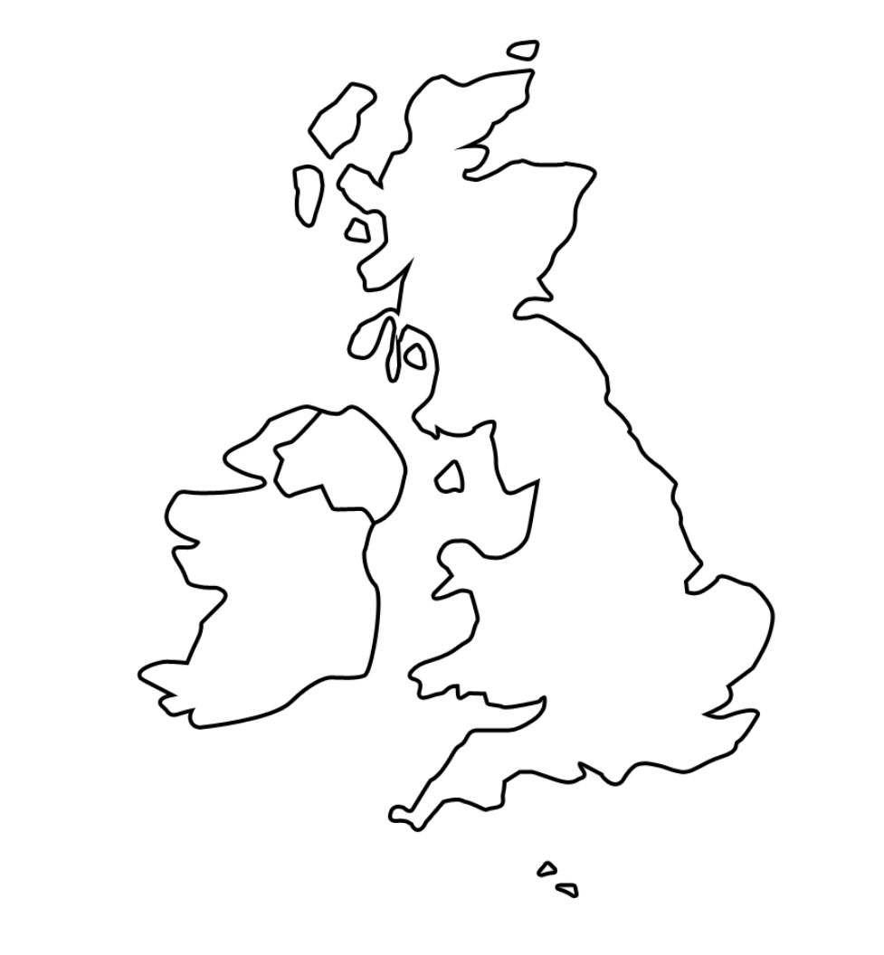Can you locate the 5 weather stations on the above map

In addition there is data provided for 3 overseas locations. Can you identify where they are

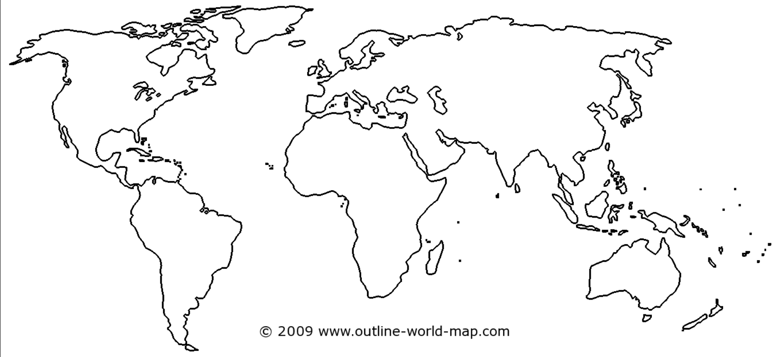

**Section 2**

You should be able to answer the following questions

What does the large data set show and what are the 11 variables measured?

Which two periods of time are included in the data set?

Did anything significant happen weather wise in either of the 2 time periods?

**Section 3**

Which stations are:

Coastal?

Inland?

Overseas?

Most southern?

Most northern?

Northern hemisphere?

Southern hemisphere?

Which have the highest/lowest altitude

Is there anything significant weather wise you should be aware of for the overseas stations?

**Section 4**

What is the Beaufort scale and what does it measure?

How do you measure cloud cover ?

What unit of measurement is used for cloud cover?

What is a knot?

What is measured in knots?

How do you measure a gust of wind?

How do your measure daily mean pressure?

What is daily mean pressure?

What is daily maximum relative humidity?

What is cardinal direction?

How is visibility measured?

If something is recorded as Tr what does this mean?

**Section 5**

Use the internet to find definitions for the following

Population

Sample

Census

Sampling unit

Sampling

Give an example of each

**Section 6 Sampling**

|  |  |  |  |
| --- | --- | --- | --- |
|  | example | advantage | disadvantage |
| Simple random  sampling |  |  |  |
| Systematic |  |  |  |
| Stratified |  |  |  |
| Quota |  |  |  |
| Opportunity/ convenience |  |  |  |

**Section 7** What is meant by:

Qualitative data

Quantitative data

Discrete data

Continuous data

Class boundary

Class width

Midpoint

