Geography A Level

We are so delighted you want to take your Geographical understanding even further and deeper! To get yourself ready for study at A Level here are a list of ideas for things to keep you busy over the summer:

* Keep watching the news – can you find links to ideas or processes you have already studied? Where do you get your information from? TikTok? BBC? Newspapers? Each one has inherent bias, and you should be aware of that when consuming them.
* Look at the specification for Year 12 – we will be starting with Global Migration and Glaciated Landscapes – are you doing anything or going anywhere this summer that is affected or involved in either of these themes? What can you find out about those places in relation to the topics?
* Read. Read. Read. You’ll find a list of books on our firefly page (along with a copy of the summer prep work). The more you read, the more you’ll have to say in our class discussions.
* Get a free subscription to Water Bear ([waterbear.com](http://www.waterbear.com)) and watch anything that is of interest to your geographical passions!
* 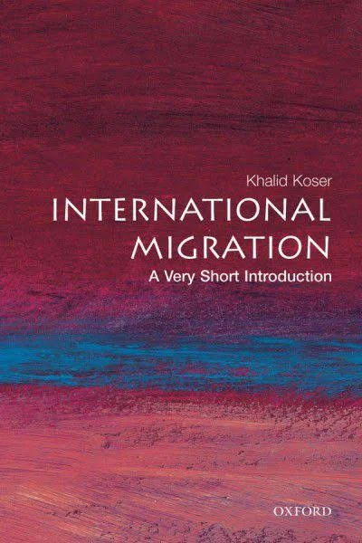Get out and explore the world. It might be the local area around you, it might be further afield. Wherever it is, go out and look at that place through a geographical lens. What human geography do you see? What physical geography? How is it interlinked and interdependent with other places? How? What was it like in the past? How has that affected how it is today? How is it represented in media and how does that affect how we perceive it?

Summer Prep Work

Please do the following and bring to your first lesson in September:

1. Read Khalid Koser’s ***‘A very short introduction: International Migration***’ as a good preparation for your first human topic. Write a short (no more than 500 words) response to the question ‘why do so few people migrate?’
2. Watch a documentary or film about glaciers – BBC iPlayer has “***Into the Ice***” available to watch, or you could rent “***Chasing Ice***” from <https://chasingice.com/>. Note down questions arising or points that has surprised you ready to discuss in your first lesson with your glaciation teachers.
3. **Optional:** make an entry into the Royal Geographical Society’s Young Geographer of the Year competition OR the joint RGS & Financial Time essay competition. Details of both can be found at [rgs.org/schools/competitions/](https://www.rgs.org/schools/competitions/). Email your entry in to Ms Higgs at the start of term/before the deadline.

Geography A Level

We are so delighted you want to take your Geographical understanding even further and deeper! To get yourself ready for study at A Level here are a list of ideas for things to keep you busy over the summer:

* Keep watching the news – can you find links to ideas or processes you have already studied? Where do you get your information from? TikTok? BBC? Newspapers? Each one has inherent bias, and you should be aware of that when consuming them.
* Look at the specification for Year 12 – we will be starting with Global Migration and Glaciated Landscapes – are you doing anything or going anywhere this summer that is affected or involved in either of these themes? What can you find out about those places in relation to the topics?
* Read. Read. Read. You’ll find a list of books on our firefly page (along with a copy of the summer prep work). The more you read, the more you’ll have to say in our class discussions.
* Get a free subscription to Water Bear ([waterbear.com](http://www.waterbear.com)) and watch anything that is of interest to your geographical passions!
* A book cover with text

  Description automatically generated with low confidenceGet out and explore the world. It might be the local area around you, it might be further afield. Wherever it is, go out and look at that place through a geographical lens. What human geography do you see? What physical geography? How is it interlinked and interdependent with other places? How? What was it like in the past? How has that affected how it is today? How is it represented in media and how does that affect how we perceive it?

Summer Prep Work

Please do the following and bring to your first lesson in September:

1. Read Khalid Koser’s ***‘A very short introduction: International Migration***’ as a good preparation for your first human topic. Write a short (no more than 500 words) response to the question ‘why do so few people migrate?’
2. Watch a documentary or film about glaciers – BBC iPlayer has “***Into the Ice***” available to watch, or you could rent “***Chasing Ice***” from <https://chasingice.com/>. Note down questions arising or points that has surprised you ready to discuss in your first lesson with your glaciation teachers.
3. **Optional:** make an entry into the Royal Geographical Society’s Young Geographer of the Year competition OR the joint RGS & Financial Time essay competition. Details of both can be found at [rgs.org/schools/competitions/](https://www.rgs.org/schools/competitions/). Email your entry in to Ms Higgs at the start of term/before the deadline.