**Summer Preparation 1: Women in Literature**

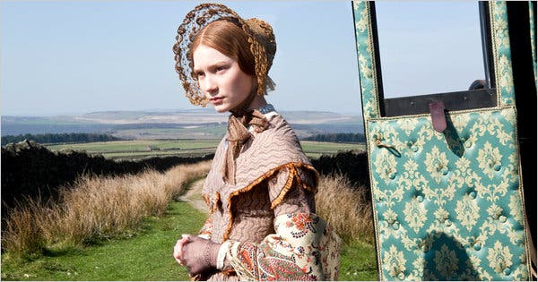

**Task 1: *Jane Eyre***

1. Read *Jane Eyre* by the start of the autumn term.
2. Create a concise chapter summary of a few sentences after reading each chapter to help you map the order of events and the novel’s structure.
3. Make notes / spider diagrams / mind-maps consisting of quotations and notes about the main characters (Jane Eyre, Mr Rochester, Helen Burns, Bertha Mason and St John Rivers) and brief bullet point notes on the minor characters (Aunt Reed, John Reed, Georgiana and Eliza, Mr Brocklehurst, Miss Temple, Mrs Fairfax, Grace Poole, Blanche Ingram, the Rivers sisters, Rosamund Oliver).

Be prepared to show your teacher your notes and discuss your first impressions of the novel in the first lessons of the course.

**Task 2: Wider reading**

Half of your exam for Women in Literature involves analysing an extract from a novel, and linking it contextually to a range of other literary texts you have read independently as part of the course.

So during the summer, we want you to:

1. Choose a minimum of one novel from the Women in Literature Wider Reading recommended texts to read before September (see below).
2. Read and make notes on this text, in your wider reading journal (see …).
3. Bookmark or make a note of any passages you think would be particularly interesting to analyse as extracts (up to about 2 pages long).
4. Write a 300-400 word summary (avoiding ‘spoilers’) and recommendation about the text to share with your A Level class, detailing:
   * Key characters, events, ideas and issues explored in the novel, which relate to the topic of Women in Literature.
   * What you found interesting about the writer’s techniques.
   * What you enjoyed about the novel.
   * Why other students should read it as part of their study of Women in Literature.

**Recommended Women in Literature wider reading**

***Emma* – Jane Austen (1815)**

Beautiful, clever, rich – and single – Emma Woodhouse is perfectly content with her life and sees no need for either love or marriage. Nothing, however, delights her more than interfering in the romantic lives of others. But when she ignores the warnings of her good friend Mr Knightley and attempts to arrange a suitable march for her protegee Harriet Smith, her carefully laid plans soon unravel and have consequences that she never expected.

***Wuthering Heights* – Emily Bronte (1847)**

Heathcliff, an orphan, is raised by Mr Earnshaw as one of his own children. Hindley despises him but wild Cathy becomes his constant companion, and he falls deeply in love with her. But when she will not marry him, Heathcliff's terrible vengeance ruins them all. Yet still his and Cathy's love will not die.

***The Bell Jar* – Sylvia Plath (1963)**

When Esther Greenwood wins an internship on a New York fashion magazine in 1953, she is elated, believing she will finally realise her dream to become a writer. But in between the cocktail parties and piles of manuscripts, Esther's life begins to slide out of control. She finds herself spiralling into serious depression as she grapples with difficult relationships and a society which refuses to take her aspirations seriously.

***Wide Sargasso Sea* – Jean Rhys (1966)**

Born into the oppressive, colonialist society of 1930s Jamaica, white Creole heiress Antoinette Cosway meets a young Englishman who is drawn to her innocent beauty and sensuality. After their marriage, however, disturbing rumours begin to circulate which poison her husband against her. A response to *Jane Eyre*, this classic study of betrayal, a seminal work of postcolonial literature, is Jean Rhys's brief, beautiful masterpiece.

***The Women’s Room* – Marilyn French (1977)**

A landmark in feminist literature, *The Women’s Room* is a biting social commentary of a world gone silently haywire. Written in the 1970s but with profound resonance today, this is a modern allegory that offers piercing insight into the social norms accepted blindly and revered so completely. It follows the transformation of Mira Ward and her circle as the women’s movement begins to have an impact on their lives.

***The Color Purple* – Alice Walker (1982)**

Set in the deep American South between the wars, *The Color Purple* is the classic tale of Celie, a young black girl born into poverty and segregation. Raped repeatedly by the man she calls ‘father’, she has two children taken away from, is separated from her beloved sister Nettie and is trapped into an ugly marriage. But then she meets the glamorous Shug Avery, singer and magic-maker – woman who has taken charge of her own destiny…

***The Handmaid’s Tale* – Margaret Atwood (1985)**

Offred lives in The Republic of Gilead. To some, it is a utopian vision of the future, a place of safety, a place where everyone has a purpose, a function. But The Republic of Gilead offers Offred only one function: to breed. If she deviates, she will, like dissenters, be hanged at the wall or sent out to die slowly of radiation sickness. But even a repressive state cannot obliterate desire – neither Offred’s nor that of the two men on which her future hangs.